MTD ITSA
User Guide
Making Tax Digital for Income Tax in Tax Optimiser — getting started, connecting to HMRC, your businesses and settings, digital records, quarterly updates, annual adjustments, the tax calculation and the final declaration.
taxoptimiser.co.uk · 23 July 2026

Contents
- Getting started with MTD ITSA — What Making Tax Digital for Income Tax is, the four-step setup on your dashboard, and the difference between demo mode and live mode.
- Your details and National Insurance Number — Where your personal details go, and why your National Insurance Number is required before any submission.
- Connecting to HMRC — How to authorise Tax Optimiser to talk to HMRC, the difference between an individual and an agent connection, and when to reconnect.
- Your businesses — How Tax Optimiser retrieves your income sources from HMRC, the three business types, and what each business holds.
- Business settings: accounting type and quarterly periods — The per-business settings that shape how figures are reported: cash or accruals accounting, standard or calendar quarters, and full or consolidated expenses.
- Keeping digital records: the spreadsheet upload — How quarterly figures get into Tax Optimiser: uploading a spreadsheet, the full and consolidated example templates, and mapping your own cells.
- Quarterly updates: sending an update to HMRC — Sending a quarterly update: reading the values, confirming the declaration, and amending a quarter after it has gone.
- Annual adjustments: finishing the year — The end-of-year additions - dividends, foreign income, pensions, reliefs - that complete the year before your tax is worked out.
- Your tax calculation — Asking HMRC to work out the tax on what you have reported, the three kinds of calculation, and how to read the result.
- The final declaration and managing tax years — The once-a-year declaration that crystallises your tax bill, what must be done first, and how to re-open a year to amend it.

1. Getting started with MTD ITSA
What Making Tax Digital for Income Tax is, the four-step setup on your dashboard, and the difference between demo mode and live mode.
IN SHORT
- MTD ITSA = digital records + quarterly updates + a final declaration
- The dashboard checklist guides the four setup steps
- Demo mode sends nothing to HMRC - practise the whole journey safely
- Switch to live mode after HMRC confirms your MTD sign-up

Making Tax Digital for Income Tax Self Assessment (MTD ITSA) is HMRC’s new way of reporting self-employment and property income: you keep digital records and send HMRC a short update every quarter, then finalise the year with a single declaration instead of one big annual tax return. Tax Optimiser handles all of it.

The four steps to get set up
Your MTD ITSA Dashboard walks you through setup as a checklist — each step links to the screen that completes it, and the bar fills in as you go.
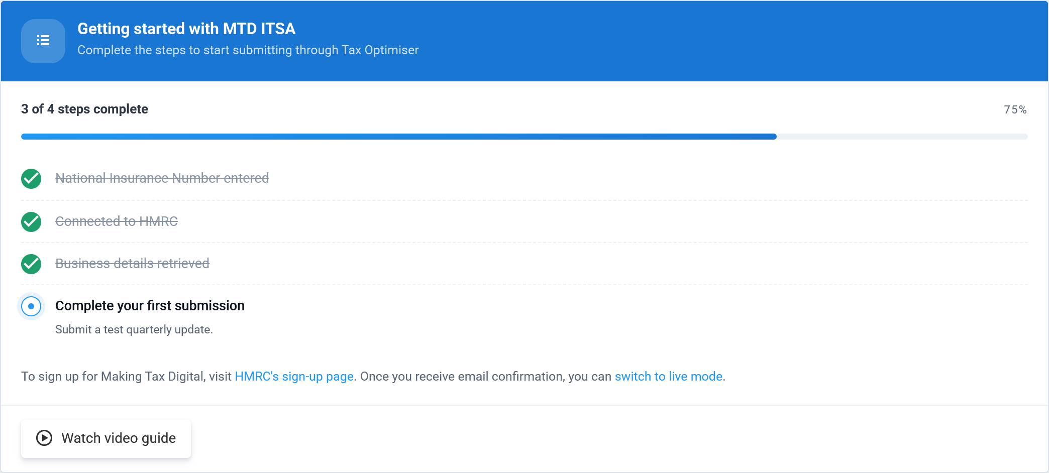
- Enter your National Insurance Number — HMRC needs it to identify you on every submission. See Your details.
- Connect to HMRC — authorise Tax Optimiser to send updates on your behalf. See Connecting to HMRC.
- Retrieve your businesses — pull your self-employment and property businesses from HMRC. See Your businesses.
- Make your first submission — send a quarterly update. See Quarterly updates.

Demo mode and live mode
Tax Optimiser starts you in demo mode, shown by the amber banner across the top. In demo mode nothing is sent to HMRC — it is a safe sandbox to practise the whole journey, from connecting through to a final declaration, without affecting your real tax account.
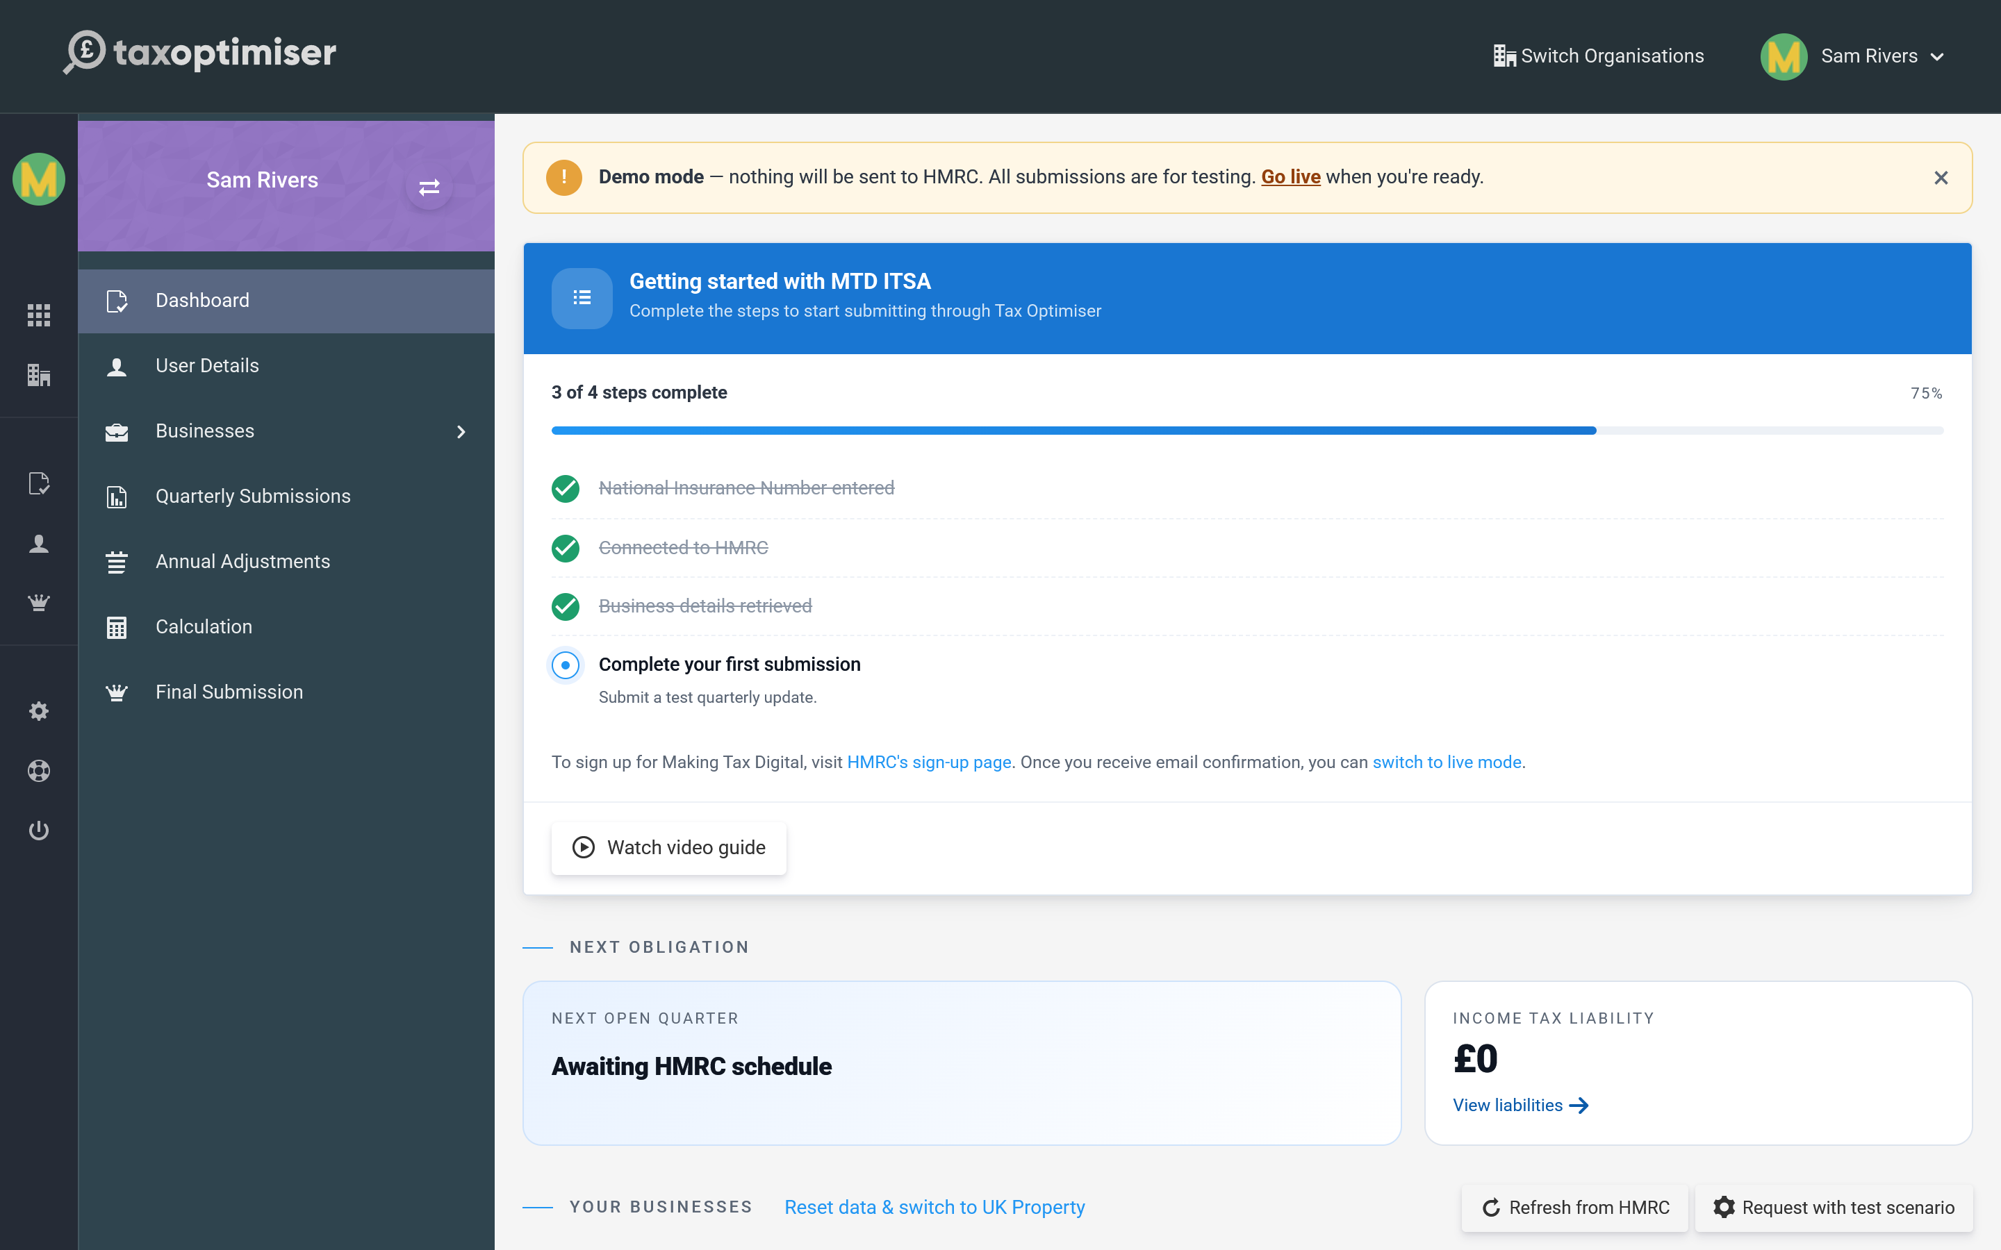
When you have signed up for MTD with HMRC and received their confirmation, you switch to live mode so your updates count for real. This is currently a supported beta — use the Go live link on the banner and the team will help you switch over.

The rest of the journey
Once set up, the left-hand menu follows the year end to end: Your businesses and their settings, keeping digital records, sending quarterly updates, making any annual adjustments, viewing your tax calculation, and submitting the final declaration.

2. Your details and National Insurance Number
Where your personal details go, and why your National Insurance Number is required before any submission.
IN SHORT
- Your National Insurance Number is required before you can submit
- It is entered on the User Details screen and saved once
- Personal UTR, address and tax code live on the same screen

Before you can send anything to HMRC, your own details need to be on record. Open User Details from the menu.
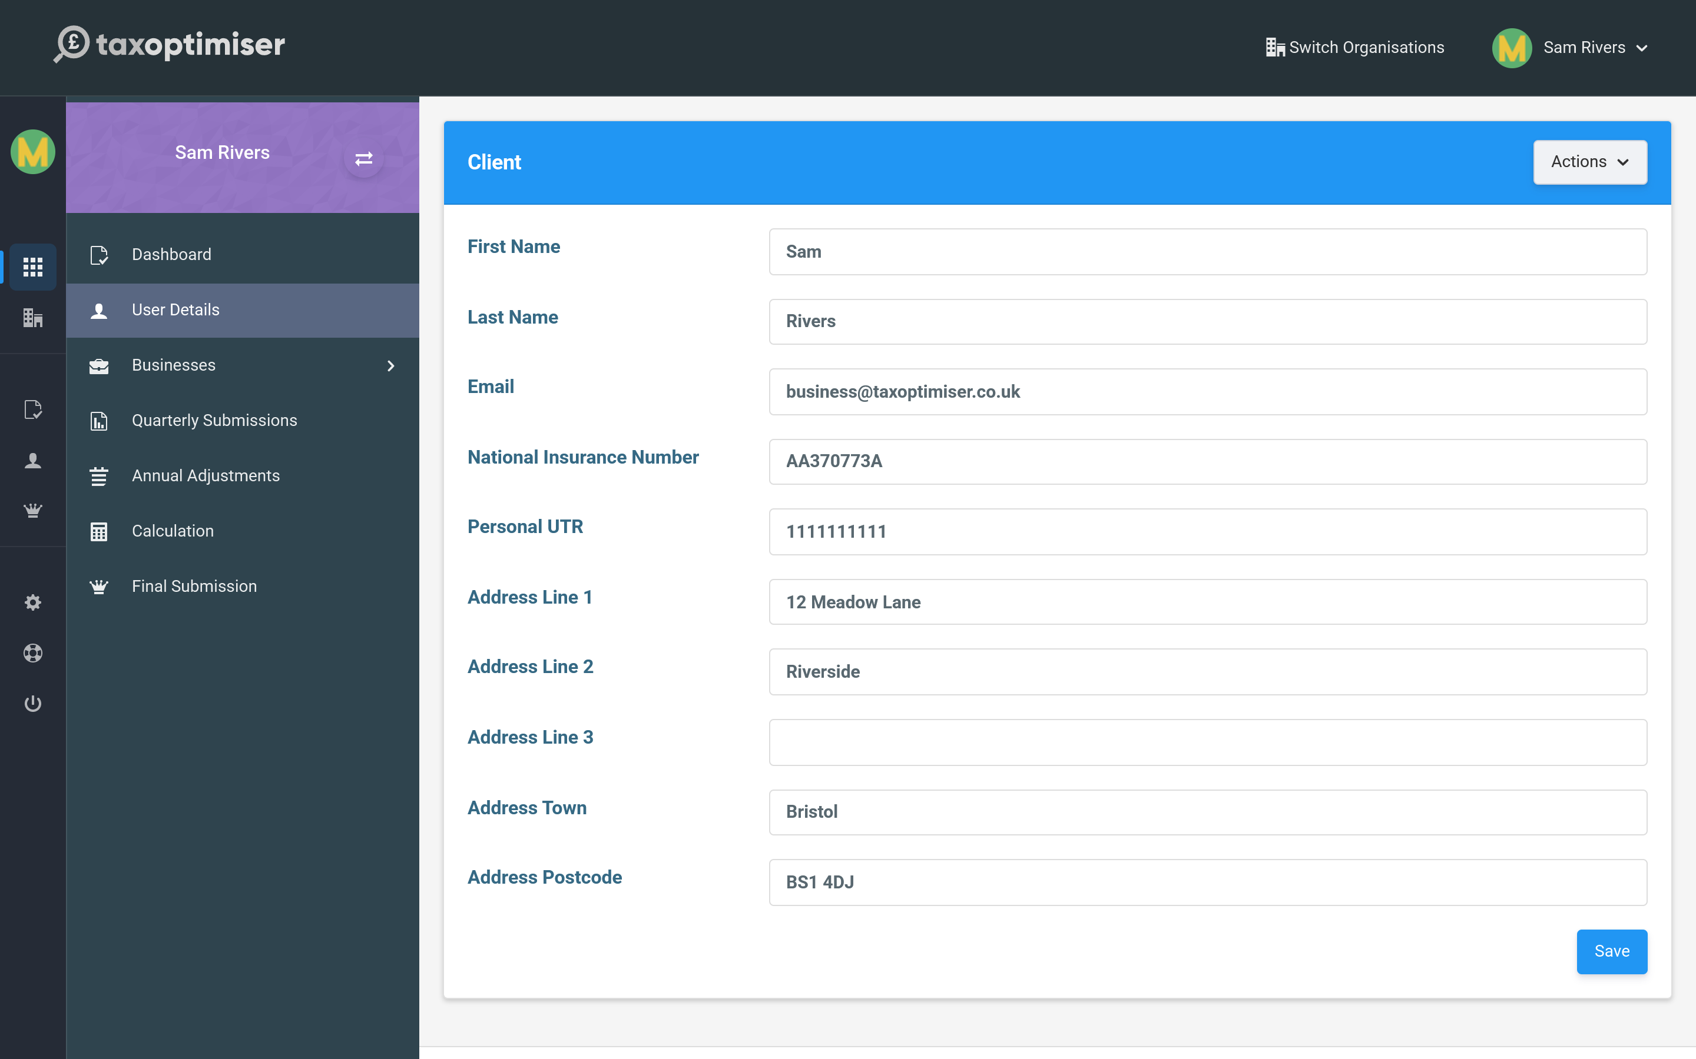

National Insurance Number
Your National Insurance Number is how HMRC ties your quarterly updates and final declaration to you. It is required — the setup checklist will not show as complete, and submissions will not go through, until it is entered. It looks like two letters, six digits and a final letter (for example AB 12 34 56 C).

The rest of the record
- Personal UTR — your 10-digit Unique Taxpayer Reference for Self Assessment. Useful to hold here for reference.
- Name and address — your personal details, kept separate from any individual business’s trading address.
- Tax code — used when estimating the tax due on your income.
Enter your details and press Save. You only need to do this once; you can come back and update it any time.

3. Connecting to HMRC
How to authorise Tax Optimiser to talk to HMRC, the difference between an individual and an agent connection, and when to reconnect.
IN SHORT
- Connecting authorises Tax Optimiser to file with HMRC for you
- Authority is granted through the Government Gateway and lasts 18 months
- Connect as an individual, or let your accountant connect as your agent
- Demo mode uses a safe dummy gateway; reconnect when authority expires

To send updates — or even to pull your businesses back from HMRC — Tax Optimiser needs your permission to talk to HMRC on your behalf. That permission is granted once, through HMRC’s own sign-in, and lasts 18 months before it needs renewing.

Connecting from the dashboard
On the setup checklist, step two is the connection. In demo mode it reads Connect to test HMRC — the safe sandbox gateway.
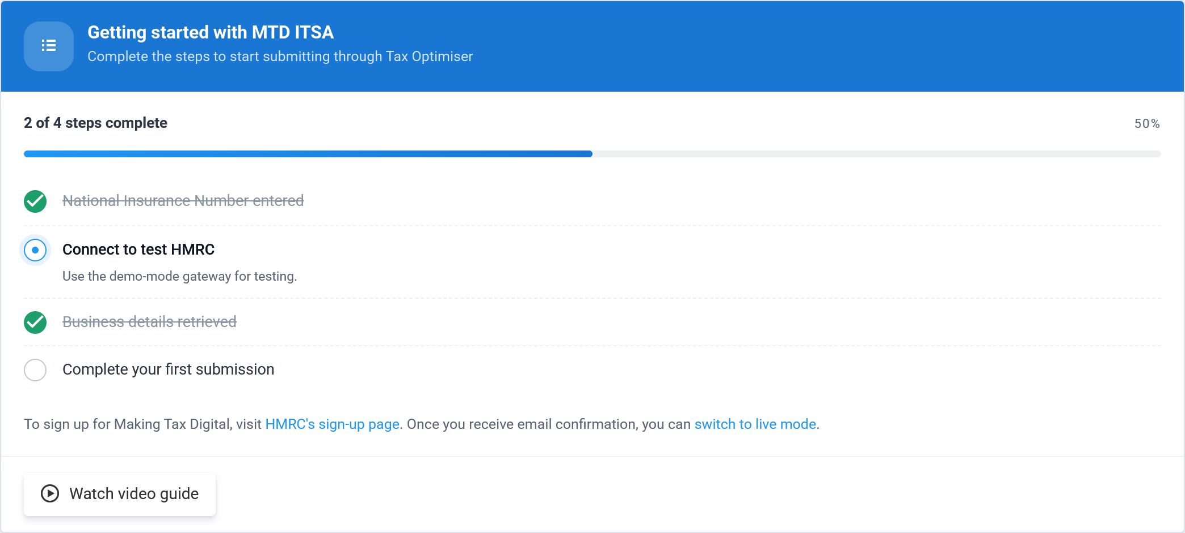
Selecting it opens HMRC’s authorisation screen. In demo mode this is the clearly-labelled dummy gateway, which behaves exactly like the real thing but sends nothing:
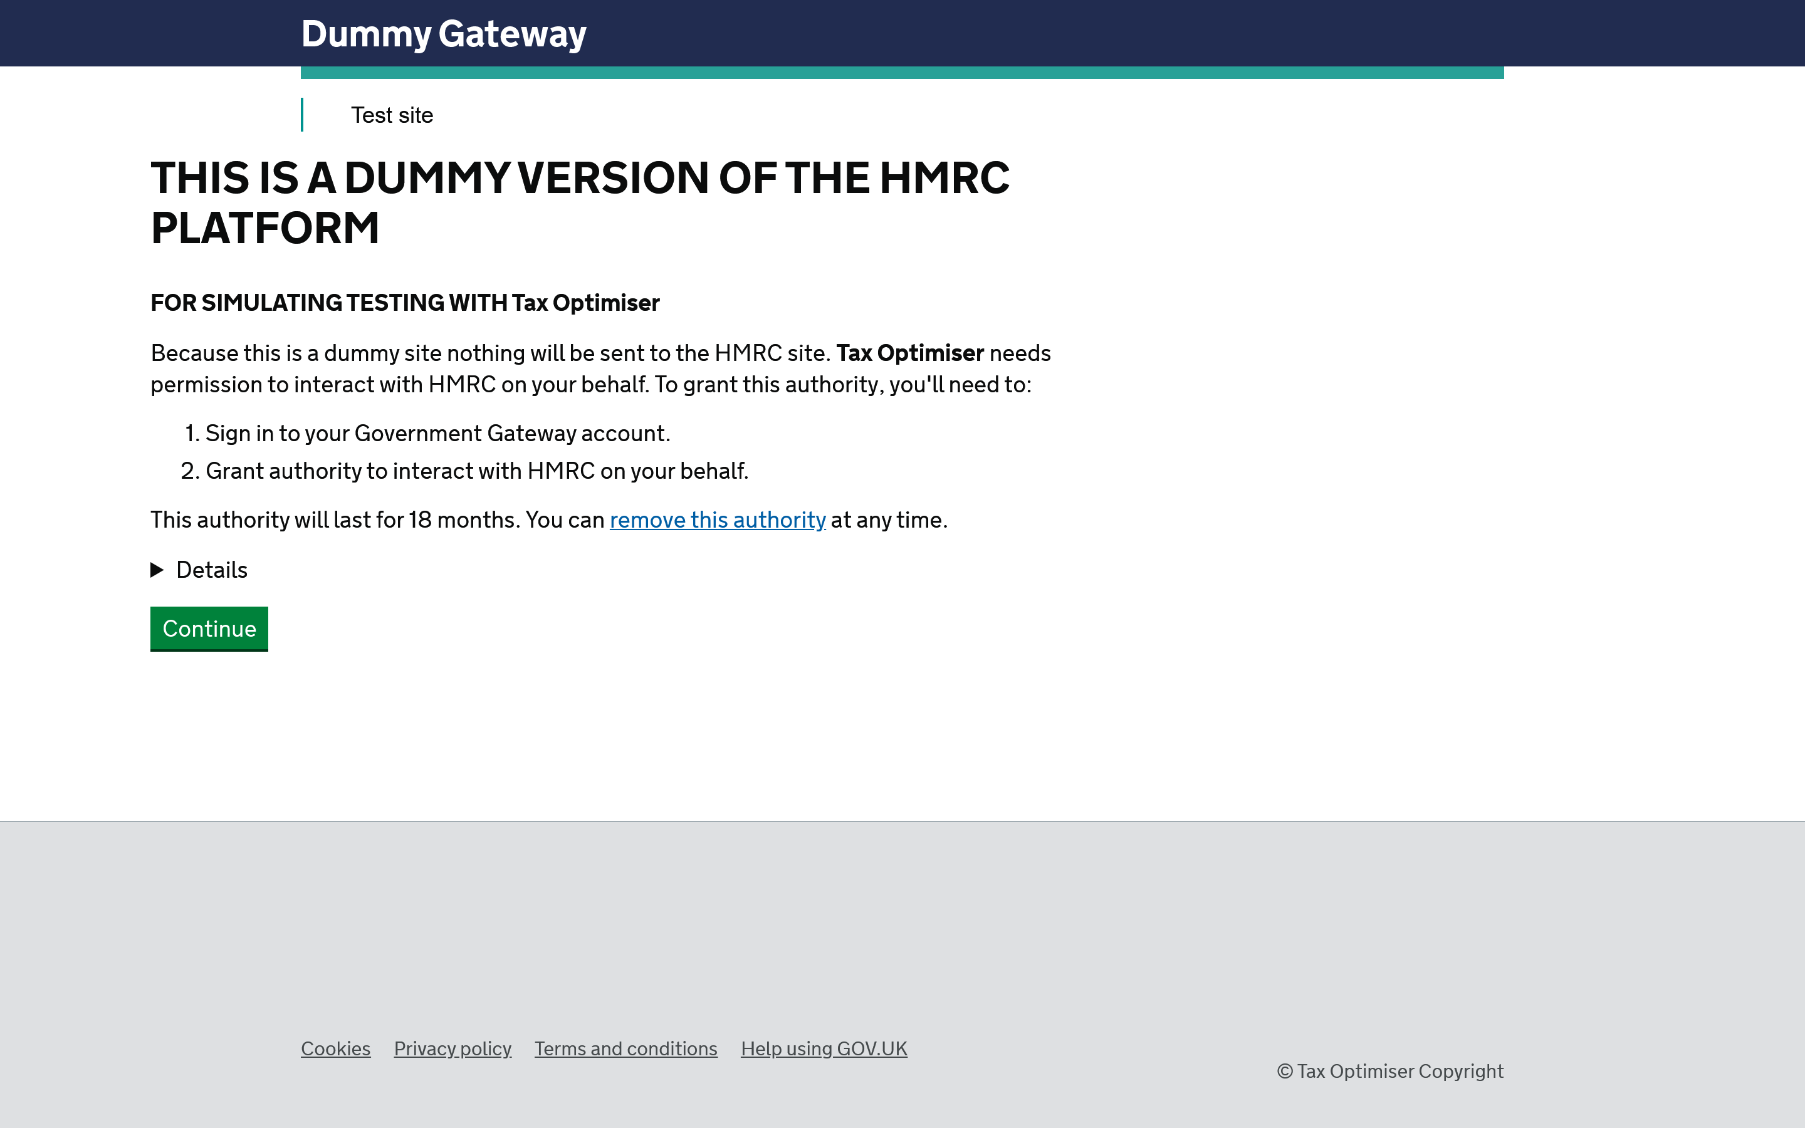
You sign in to your Government Gateway account and grant authority. Once you do, you are returned to Tax Optimiser, now connected.

Individual or agent
There are two ways the connection can be made:
Individual account — you authorise Tax Optimiser using your own Government Gateway, and updates are filed in your name. Agent account — your accountant connects on your behalf using their agent services account, and files for you. You only need one of the two.

Reconnecting
Because the authority expires after 18 months — and because you switch gateways when you move from demo to live — you may need to reconnect from time to time. If a submission ever reports that you are no longer connected, simply run the connection step again.

4. Your businesses
How Tax Optimiser retrieves your income sources from HMRC, the three business types, and what each business holds.
IN SHORT
- Retrieve businesses pulls your income sources from HMRC automatically
- Three types: self-employment, UK property, foreign property
- Each business has its own four quarterly obligations a year
- Refresh from HMRC keeps the list in step with HMRC

MTD ITSA reports each source of income separately, and HMRC already knows which ones you have. Once connected, Tax Optimiser pulls them in for you with Retrieve businesses from HMRC — no typing required. They then appear on your dashboard.

The three types of business
- Self-employment — a sole trade, such as a plumber or a consultant. Each separate trade is its own business.
- UK property — income from letting property in the UK. All your UK rentals are reported together as one property business.
- Foreign property — income from letting property overseas.

Opening a business
Select a business to see its details — its type, accounting basis, address and quarterly obligations.
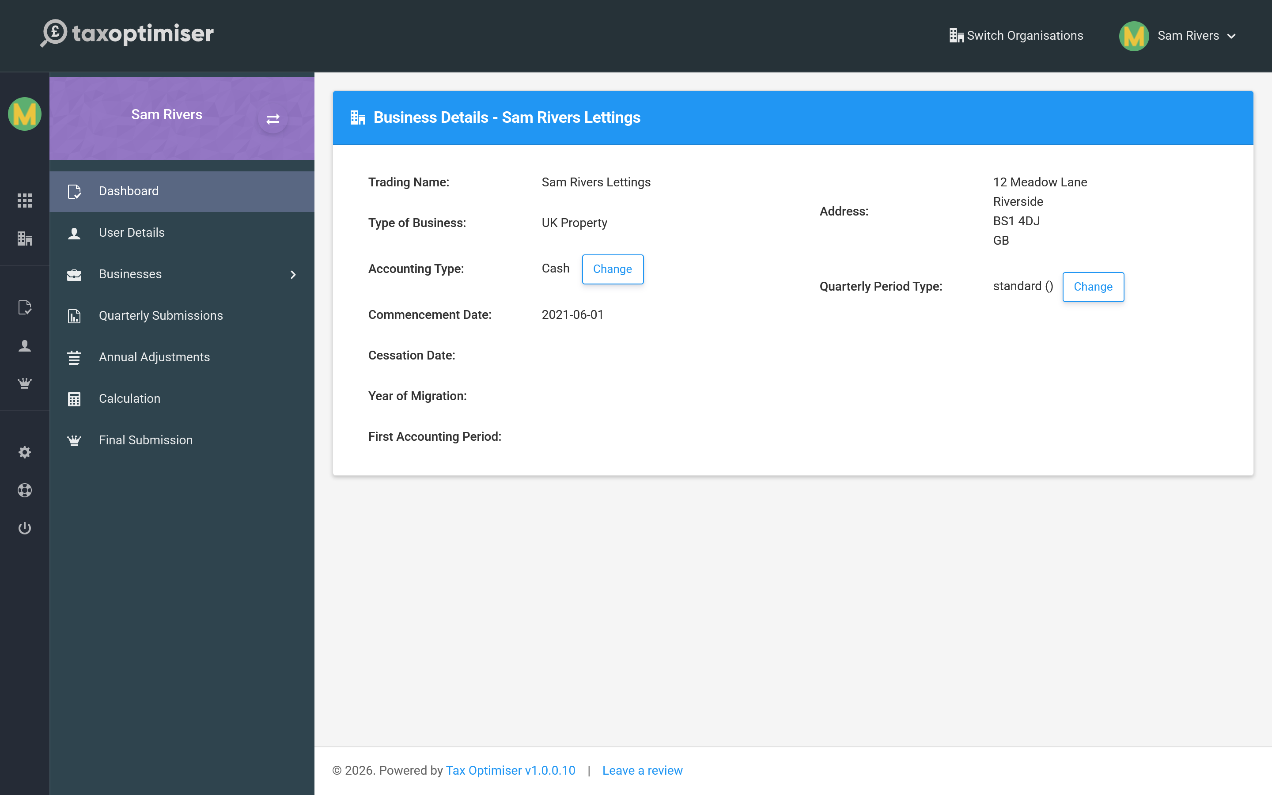
Each business carries its own set of quarterly obligations — the four updates a year you owe HMRC for that source — and you report each one independently.

Keeping it up to date
If you start a new trade or buy a rental, tell HMRC and then use Refresh from HMRC to bring the change into Tax Optimiser. The businesses you see here always mirror what HMRC holds.

5. Business settings: accounting type and quarterly periods
The per-business settings that shape how figures are reported: cash or accruals accounting, standard or calendar quarters, and full or consolidated expenses.
IN SHORT
- Cash basis counts money when it moves; accruals when earned or incurred
- Standard quarters align to the tax year; calendar quarters to month-ends
- Expenses go to HMRC itemised (full) or as one consolidated total
- Consolidated expenses require annual turnover under Â£90,000
- The late accounting date election is specialist and rarely needed

A few settings on each business decide how its figures are reported. They are shown on the business detail page, each with a Change button.
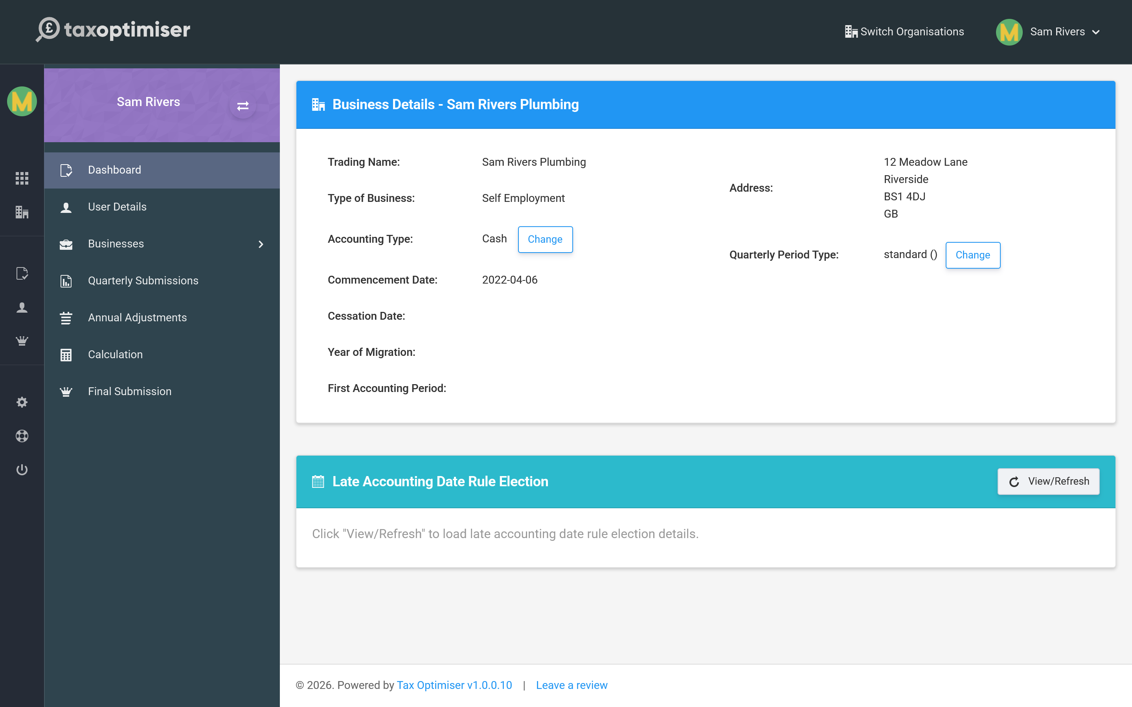

Accounting type
This is how you add your income and expenses up:
- Cash basis — you count money when it actually comes in or goes out. Simpler, and the default for most sole traders and landlords.
- Accruals (traditional) basis — you count income and costs when they are earned or incurred, regardless of when the money moves.
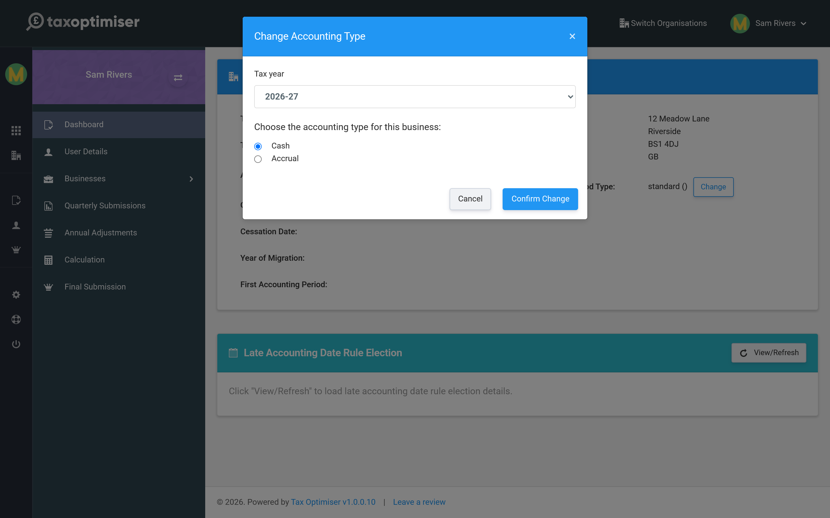
Choose the basis that matches how you report to HMRC, then Confirm Change.

Quarterly period type
This sets the dates your four quarterly updates run to:
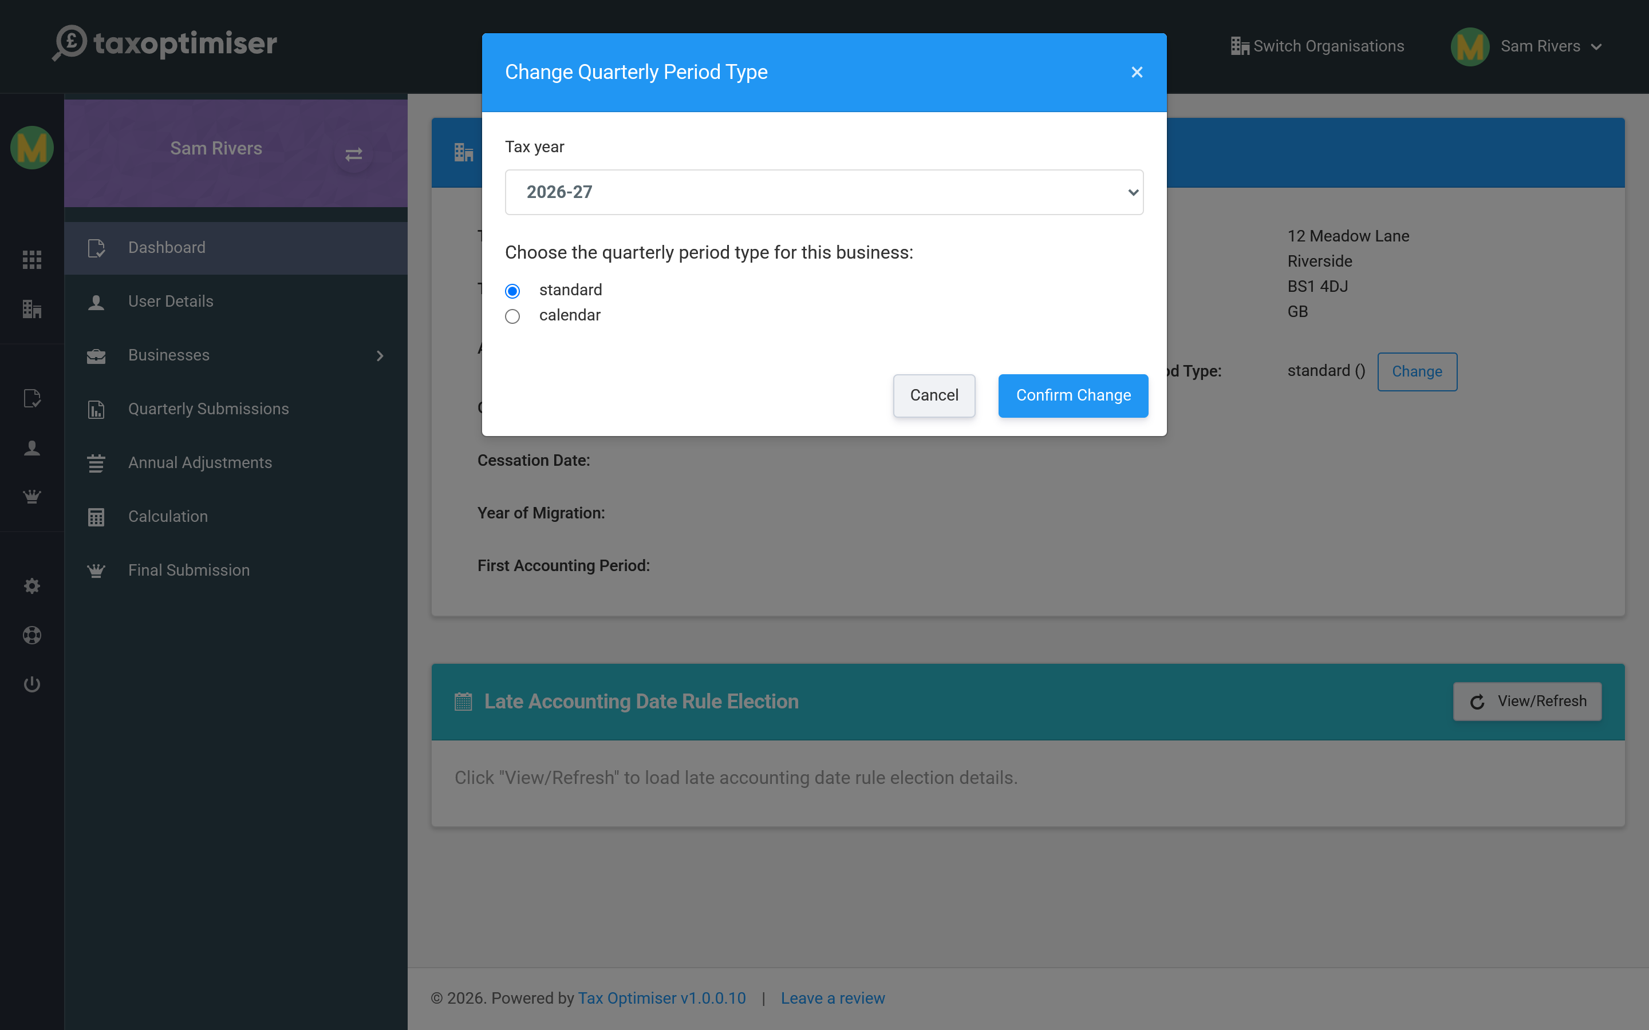
- Standard — quarters aligned to the tax year (6 April–5 July, and so on). The default.
- Calendar — quarters aligned to calendar month-ends (to 30 June, 30 September, and so on), which is often easier to reconcile against bookkeeping.

Expense reporting: full or consolidated
Each business also chooses how its expenses go to HMRC in the quarterly updates:
- Full — expenses itemised by category (admin costs, travel, cost of goods and so on), each with an allowable and a disallowable amount. The default.
- Consolidated — one single total of all allowable expenses for the period, with no category breakdown. Simpler bookkeeping for smaller businesses.
Consolidated expenses can only be used while the business earns less than £90,000 a year (annual turnover, or annual property income for a property business). Above that, HMRC rejects the update and you must report full itemised expenses.
The choice is made in the quarterly obligation’s Settings dialog — the same place you map your spreadsheet cells (see Keeping digital records) — and the current choice is shown on the business detail page. It also decides which example spreadsheet the quarterly upload offers you.

Other details
- Commencement date — when the business started, as held by HMRC.
- Late Accounting Date Rule Election — a specialist election for businesses whose accounting date sits late in the tax year; the card lets you view, apply or withdraw it. Most businesses never need it.

6. Keeping digital records: the spreadsheet upload
How quarterly figures get into Tax Optimiser: uploading a spreadsheet, the full and consolidated example templates, and mapping your own cells.
IN SHORT
- Quarterly figures are provided as a spreadsheet upload, not typed in
- Accepted formats: .xlsx, .xls, .xlsm, .csv up to 30MB
- The example template matches the default cell mapping and the business's expense reporting choice
- Consolidated businesses map a single Consolidated Expenses cell (turnover must stay under Â£90,000)
- The Settings dialog maps each figure to a sheet and cell; save it as a template
- Uploads process in the background - allow a moment for figures to appear

MTD requires your figures to come from digital records rather than being typed in by hand. In Tax Optimiser you provide each quarter’s totals as a spreadsheet, which you upload to the relevant quarter. Open any quarterly obligation and the upload panel sits on the right.
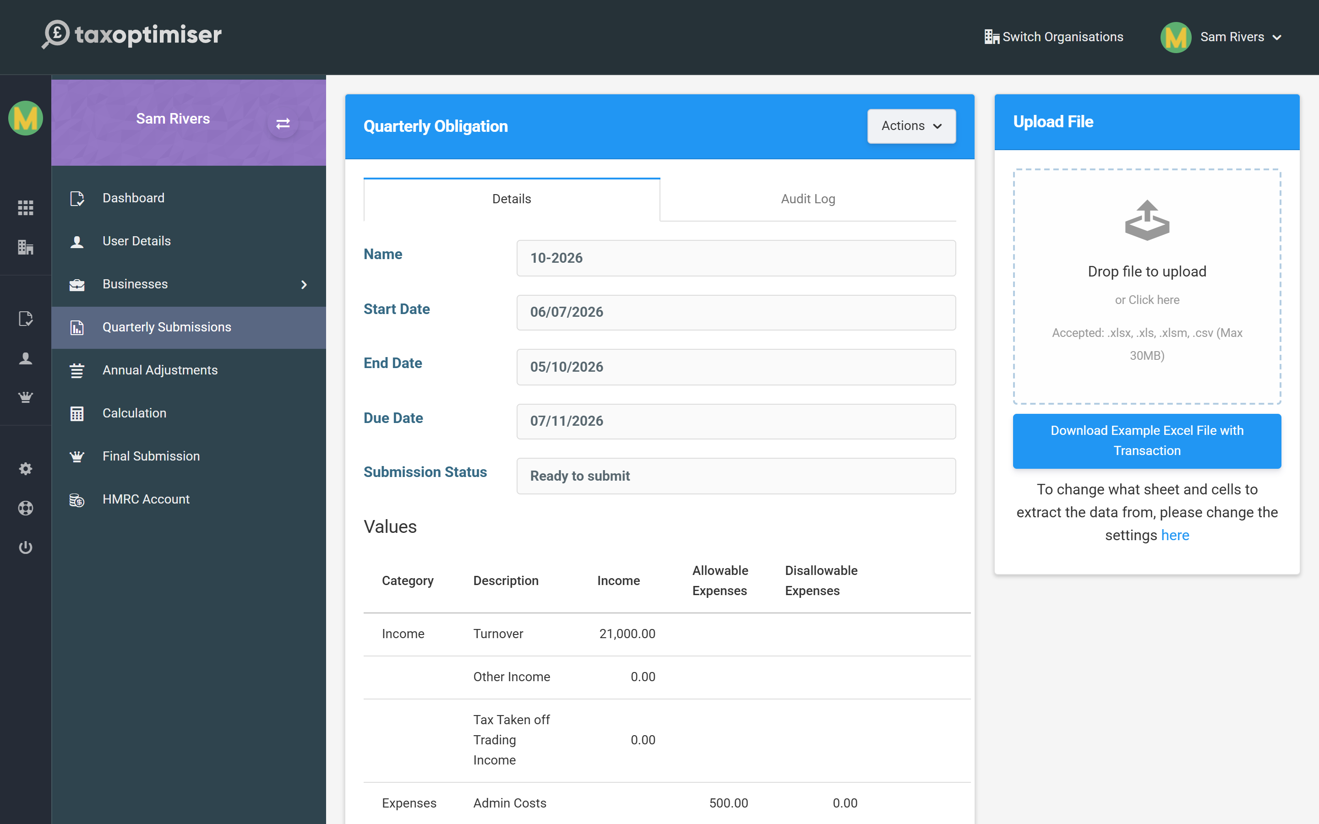

The spreadsheet
You can upload .xlsx, .xls, .xlsm or .csv files, up to 30MB. Use Download Example Excel File to get a template laid out the way Tax Optimiser expects, then fill it with your quarter’s totals. Your own bookkeeping spreadsheet works too, as long as you tell Tax Optimiser where to look (next section).
The example offered follows the business’s expense reporting choice (see Business settings):
- Full — the standard template, with a column per expense category split into allowable and disallowable amounts.
- Consolidated — a simpler template with your income figures and a single Consolidated Expenses column totalling all allowable expenses. The link is labelled (Consolidated) so you can tell which one you have.

Mapping your cells
The Settings dialog (from the obligation’s Actions menu) is where you say which sheet, and which cell, holds each figure. The defaults match the example template, but you can point any of them at the cells in your own layout.
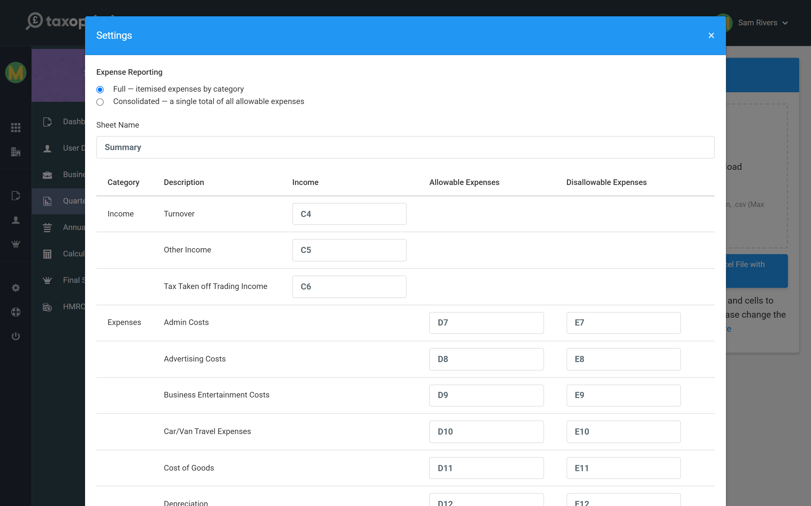
Set this once and Tax Optimiser reads the same cells from every spreadsheet you upload thereafter. You can also save the mapping as a reusable template.
The Expense Reporting choice at the top of the dialog switches the mapping to match: choose Consolidated and the itemised expense rows collapse to a single Consolidated Expenses cell (for a property business, residential financial costs and rent-a-room amounts keep their own cells, as HMRC still takes those separately).
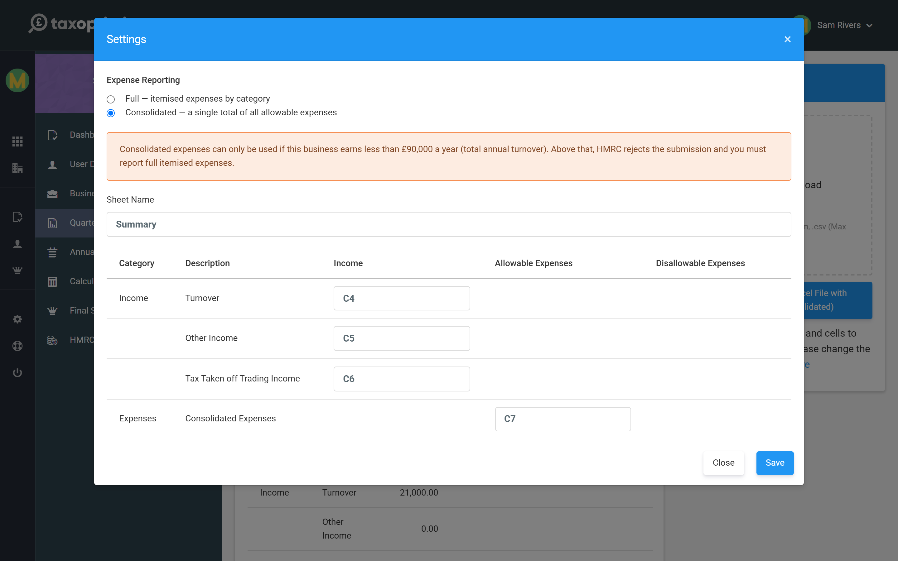
Consolidated expenses can only be used while the business earns less than £90,000 a year. The dialog reminds you when you pick it, and a quarter will not send once the year’s turnover reaches the threshold — switch back to Full and re-upload instead.
Uploads are processed in the background, so the figures may take a few moments to appear against the quarter. If they do not show straight away, give it a moment and refresh.

7. Quarterly updates: sending an update to HMRC
Sending a quarterly update: reading the values, confirming the declaration, and amending a quarter after it has gone.
IN SHORT
- Four quarterly updates a year, per business, each with a due date
- Values come from your uploaded spreadsheet - check them before sending
- Consolidated businesses show one Consolidated Expenses row (Â£90,000 turnover limit)
- Send Quarter files the update after a short accuracy declaration
- Quarterly figures are cumulative year-to-date totals
- Re-open to amend; the Audit Log records every submission

The heart of MTD is the quarterly update: four times a year, for each business, you send HMRC a running total of that source’s income and expenses. Quarterly Submissions lists them, grouped by business, with each quarter’s dates, due date and status.
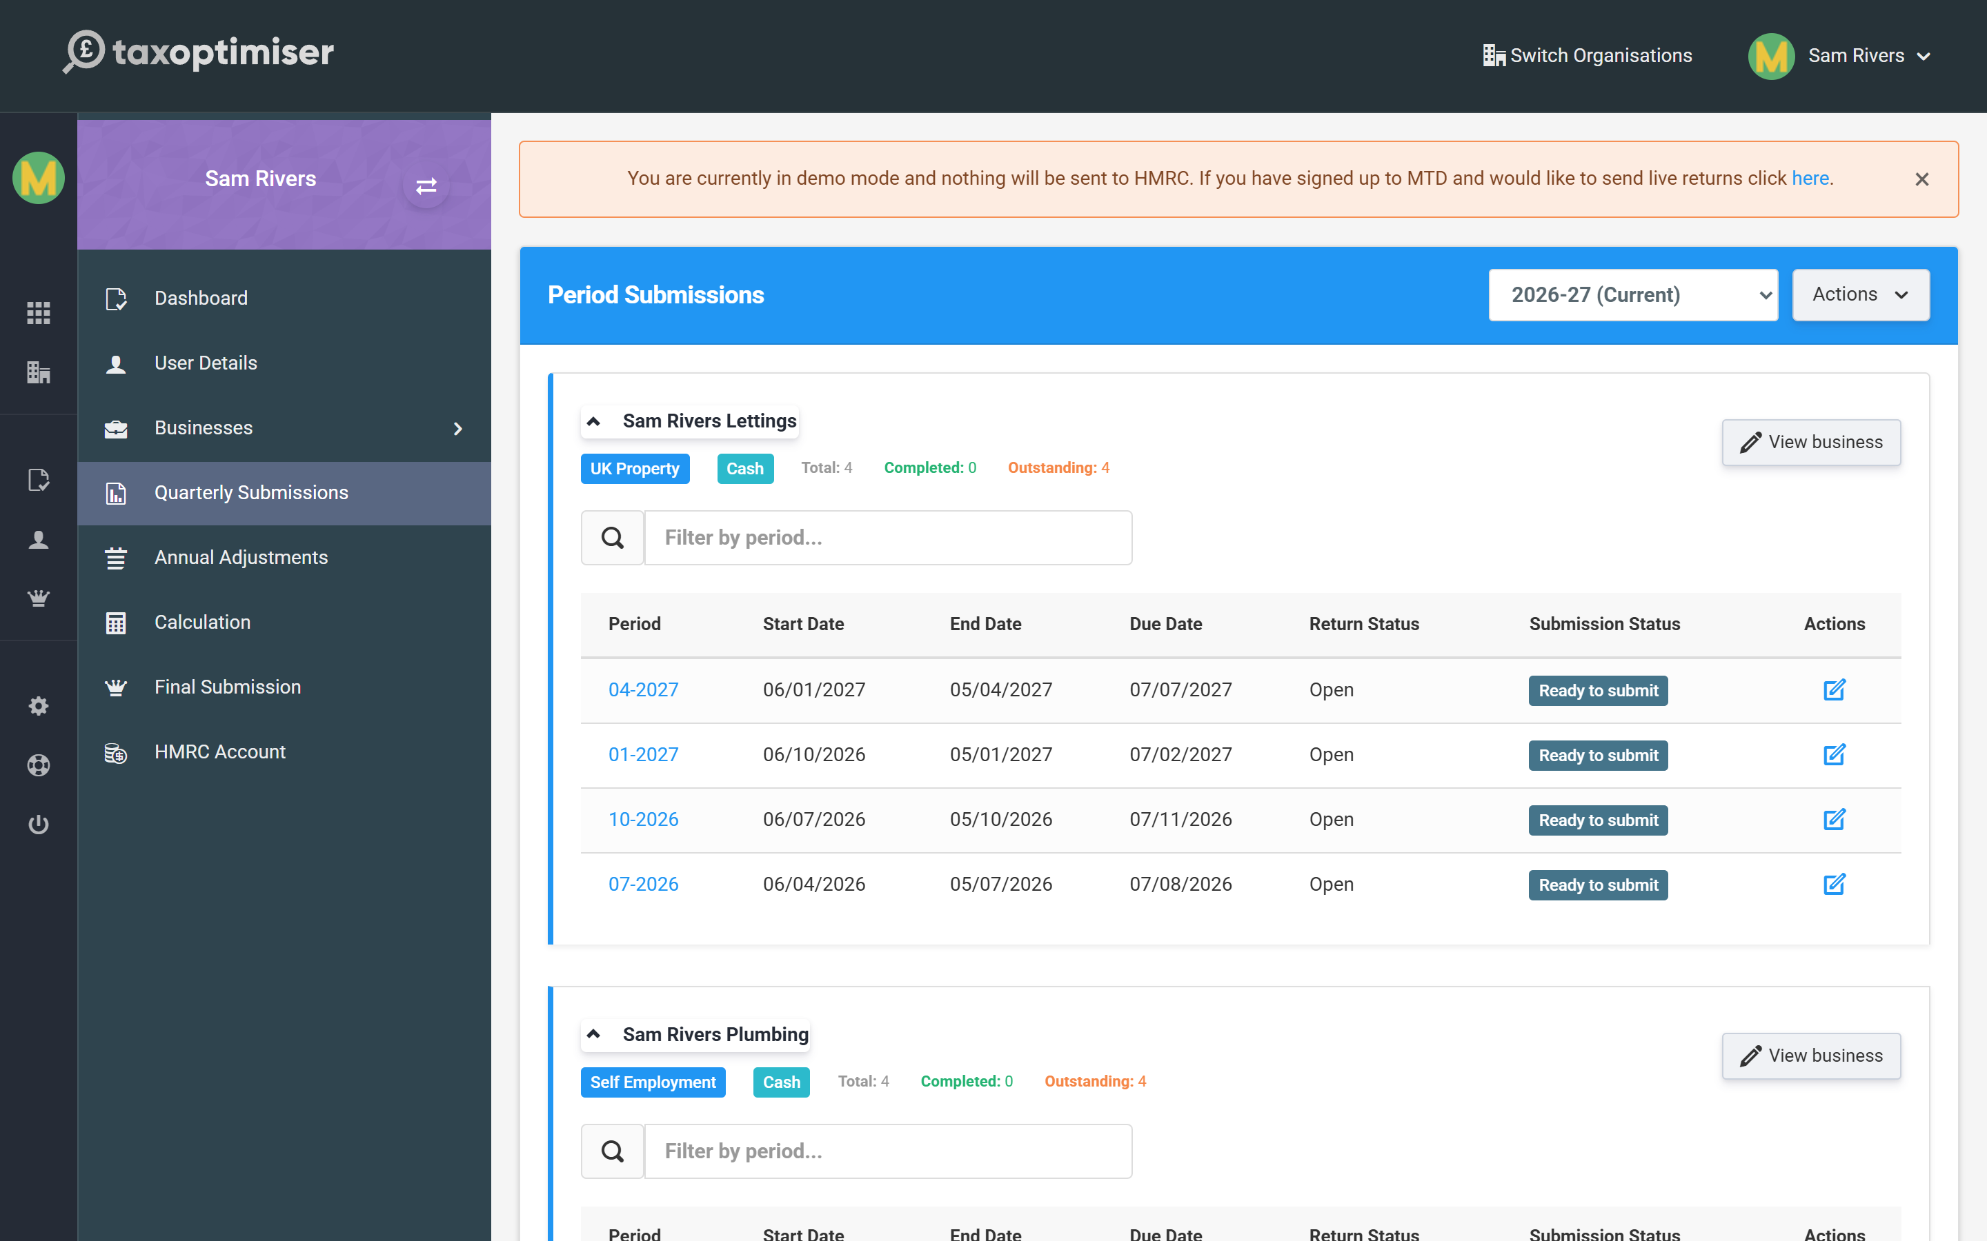

Filling a quarter
Open a quarter to see its Values — income at the top, then expenses split into allowable and disallowable. These come from the spreadsheet you upload (see Keeping digital records). Check them against your records before sending.
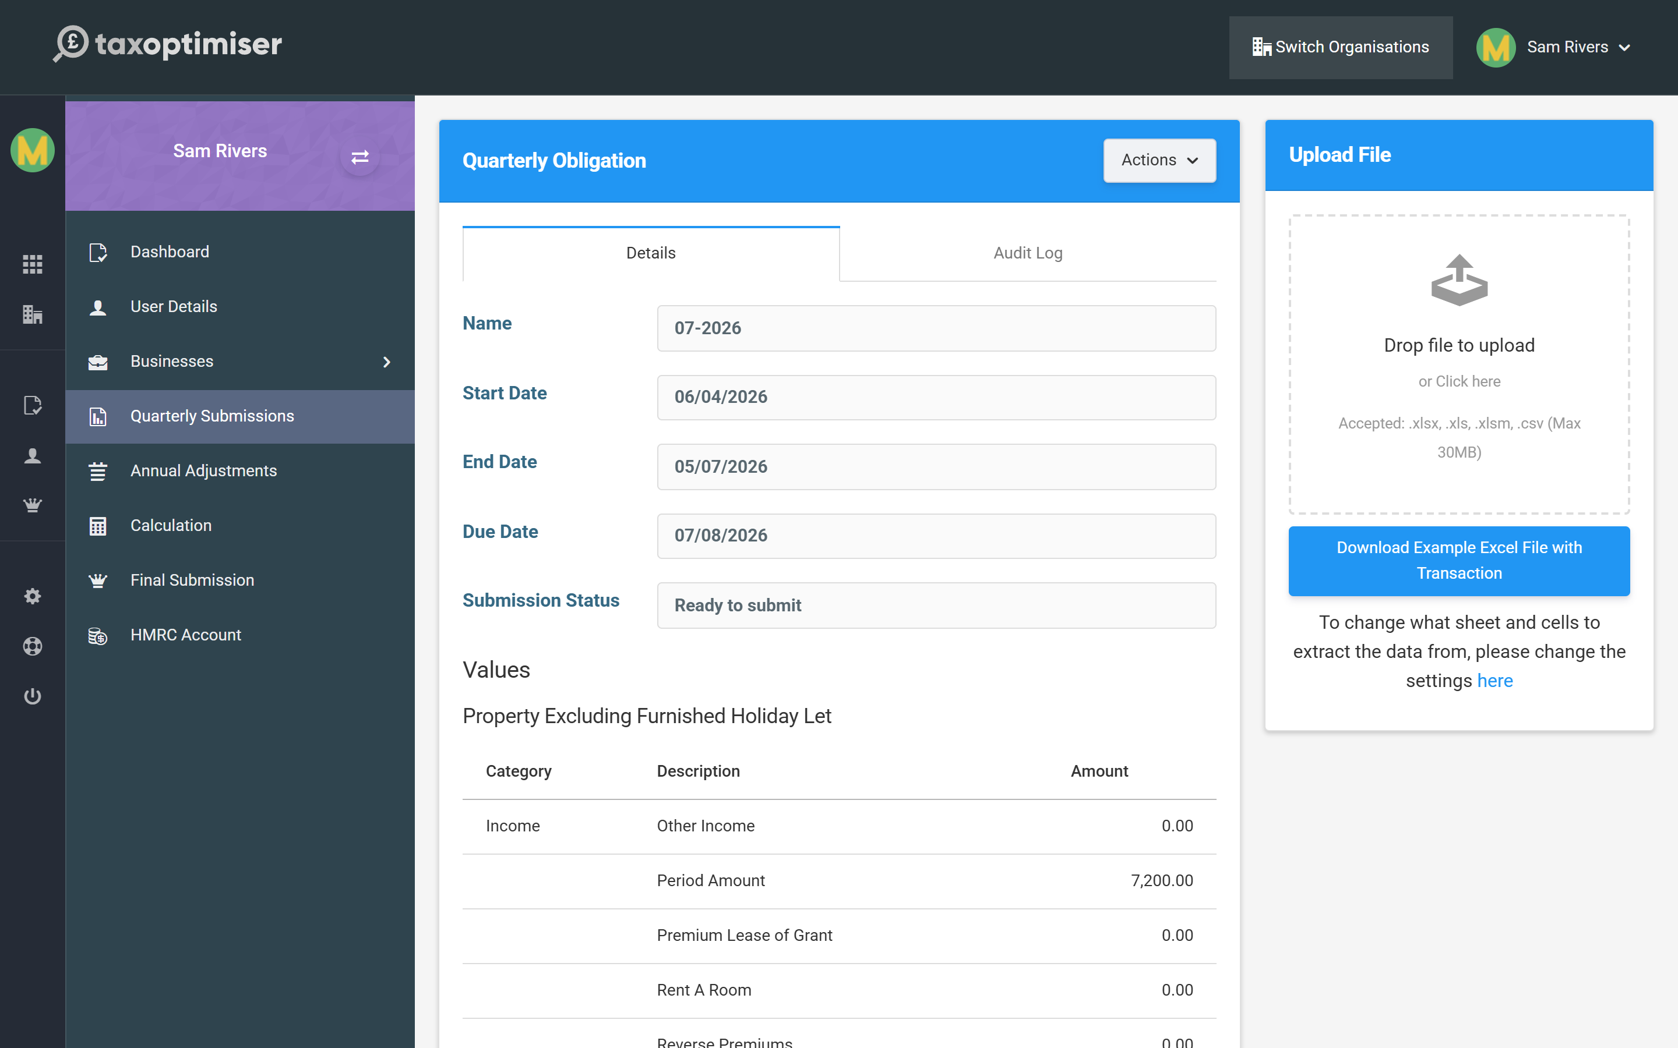
If the business reports consolidated expenses (see Business settings), the table shows a single Consolidated Expenses row instead of the category breakdown, with a banner reminding you of the £90,000 limit.
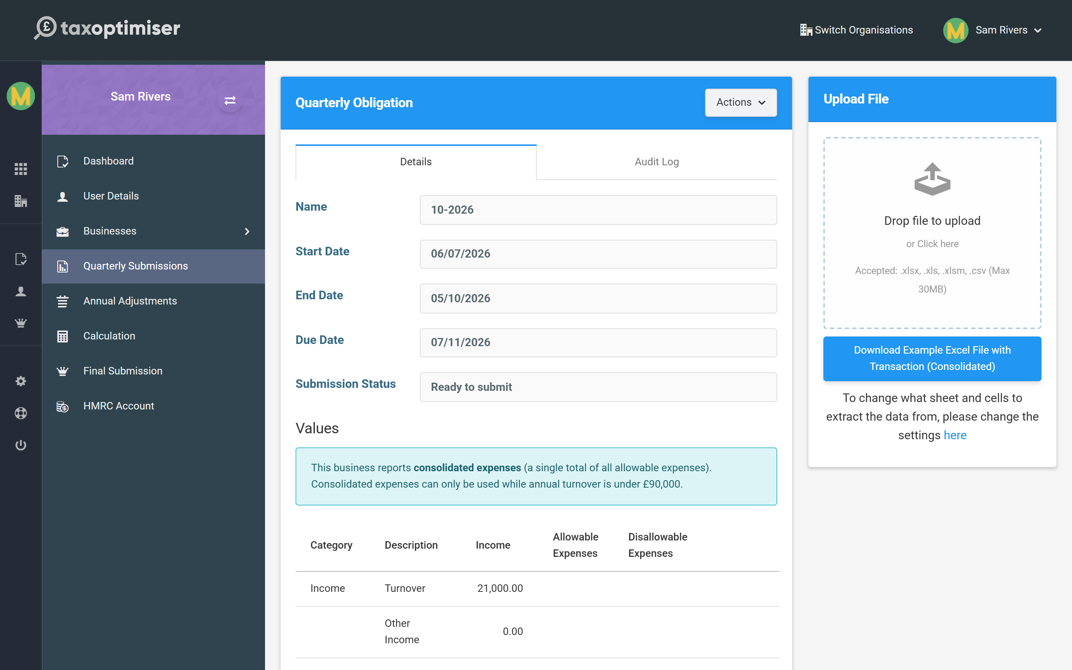
A consolidated quarter will not send once the year’s turnover reaches £90,000 — HMRC does not accept consolidated expenses above that. Tax Optimiser stops the submission with a clear message; switch the business to Full expense reporting in Settings and re-upload the quarter.

Sending it
When the figures are right, press Send Quarter. You confirm a short declaration — that the figures are accurate — and Tax Optimiser sends the update to HMRC.
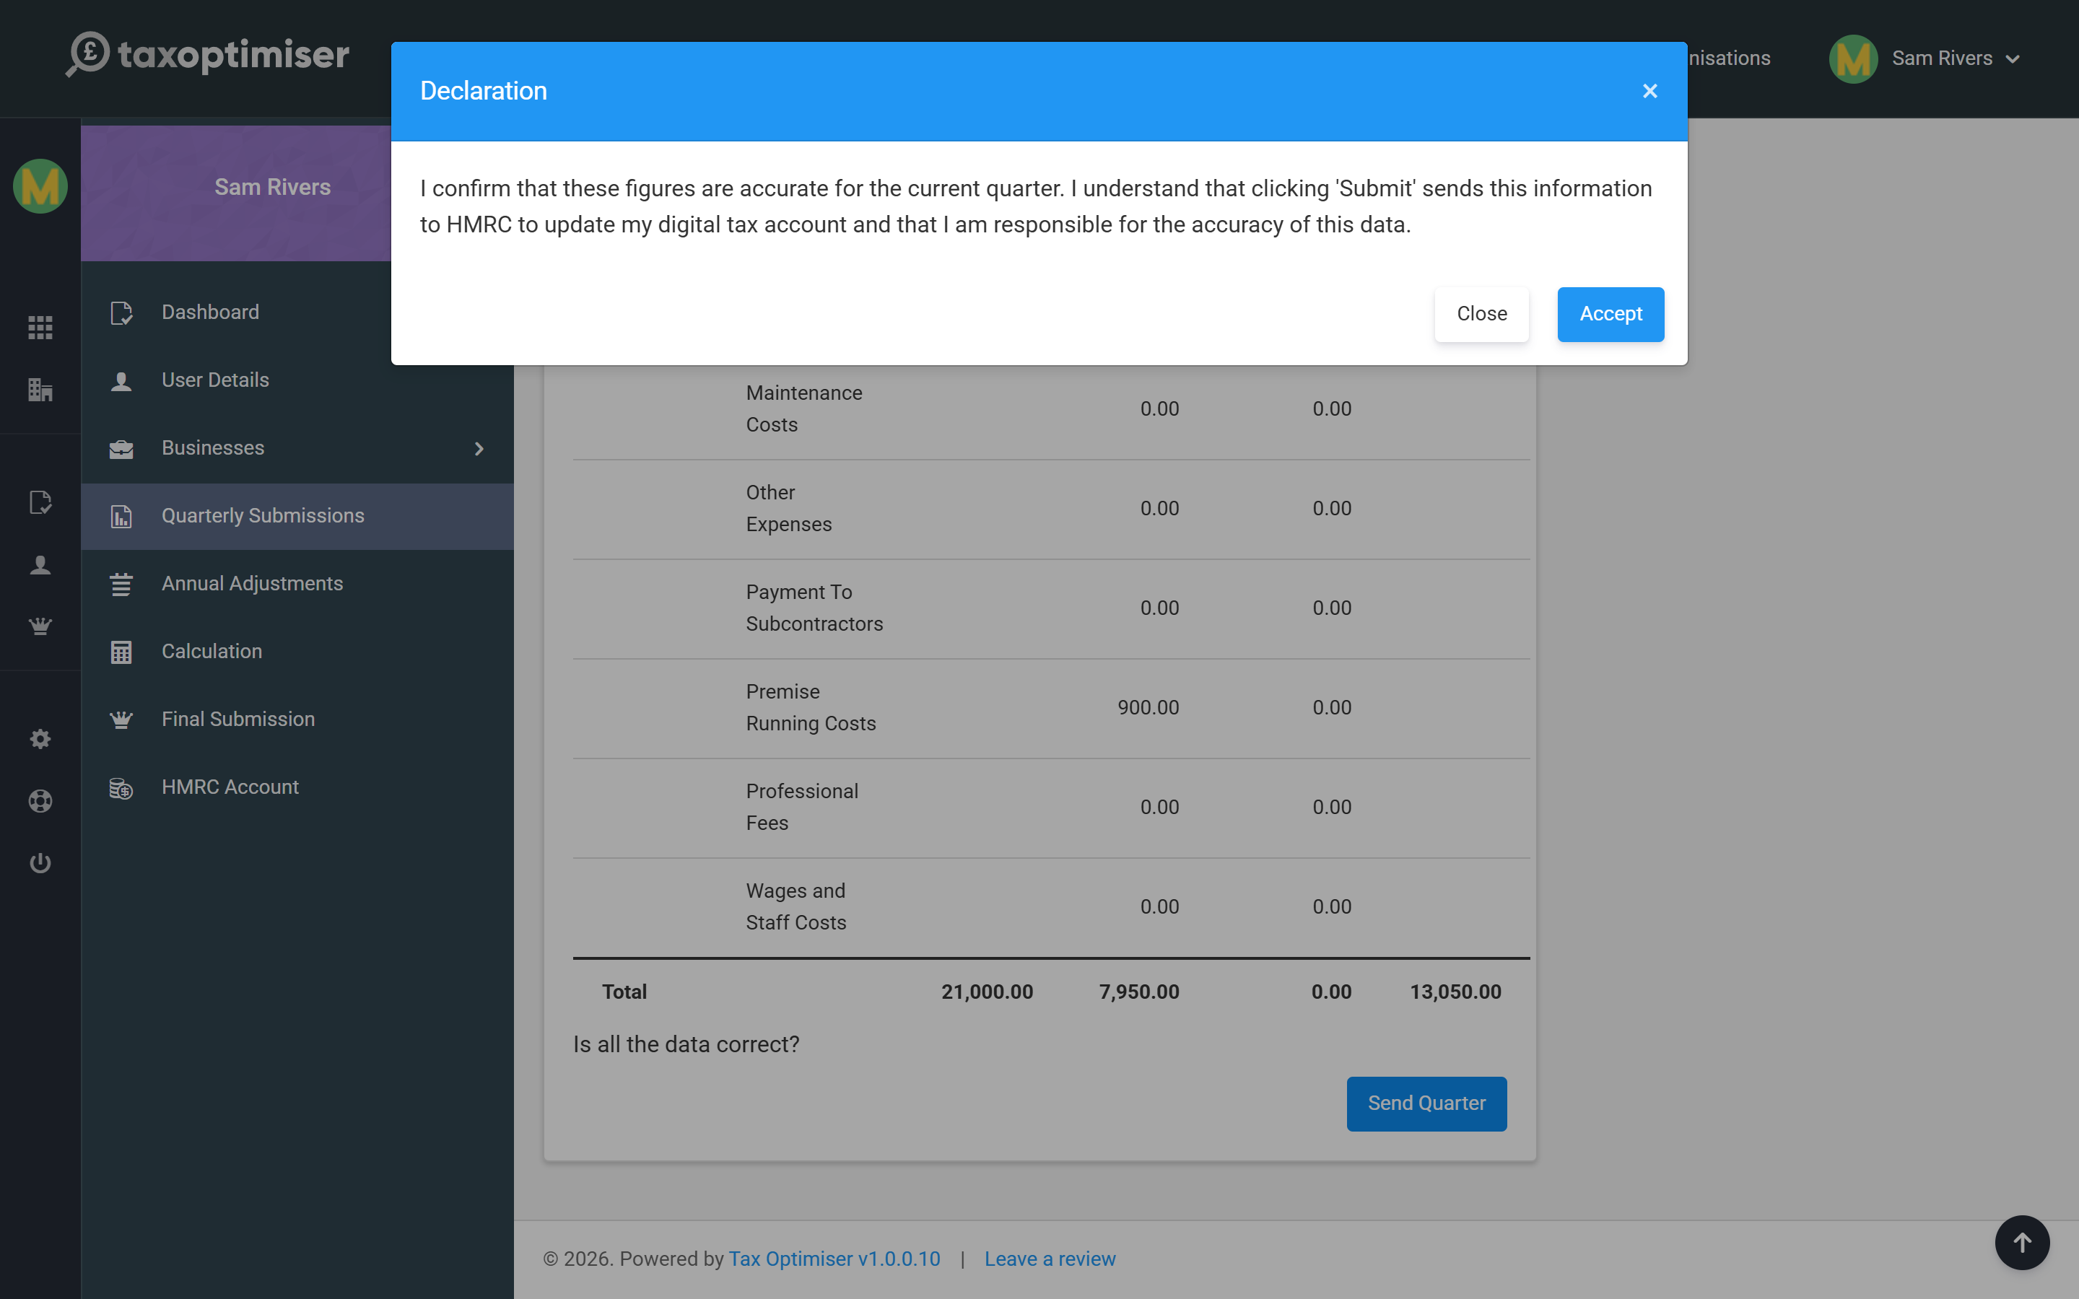
Each quarter’s figures are cumulative — you are sending the year-to-date total for that source, so a later update naturally supersedes an earlier one. Once accepted, the quarter shows as Completed.
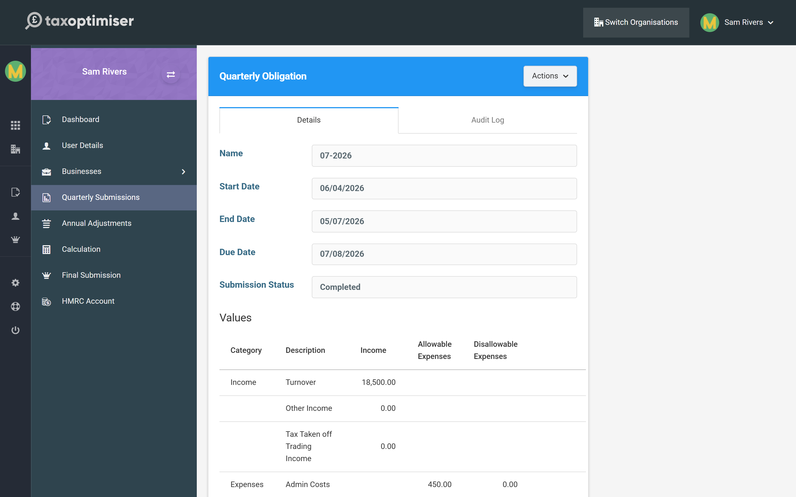

Amending and audit
Made a mistake or had a late invoice? Re-open the quarter, update the figures and send again to amend it. The Audit Log tab keeps a record of every submission for that quarter, so you can always see what was sent and when.

8. Annual adjustments: finishing the year
The end-of-year additions - dividends, foreign income, pensions, reliefs - that complete the year before your tax is worked out.
IN SHORT
- Annual adjustments hold once-a-year items outside the quarterly updates
- Add only the sections relevant to you (dividends, foreign income, pensions, reliefs)
- The income tax due figure updates live as you make changes
- Complete this before viewing the calculation and final declaration

Quarterly updates capture the everyday income and expenses of each business. But a tax year has more to it — reliefs, allowances and other kinds of income that only make sense once a year. That is what Annual Adjustments is for: the end-of-year additions that complete the picture before your tax is calculated.
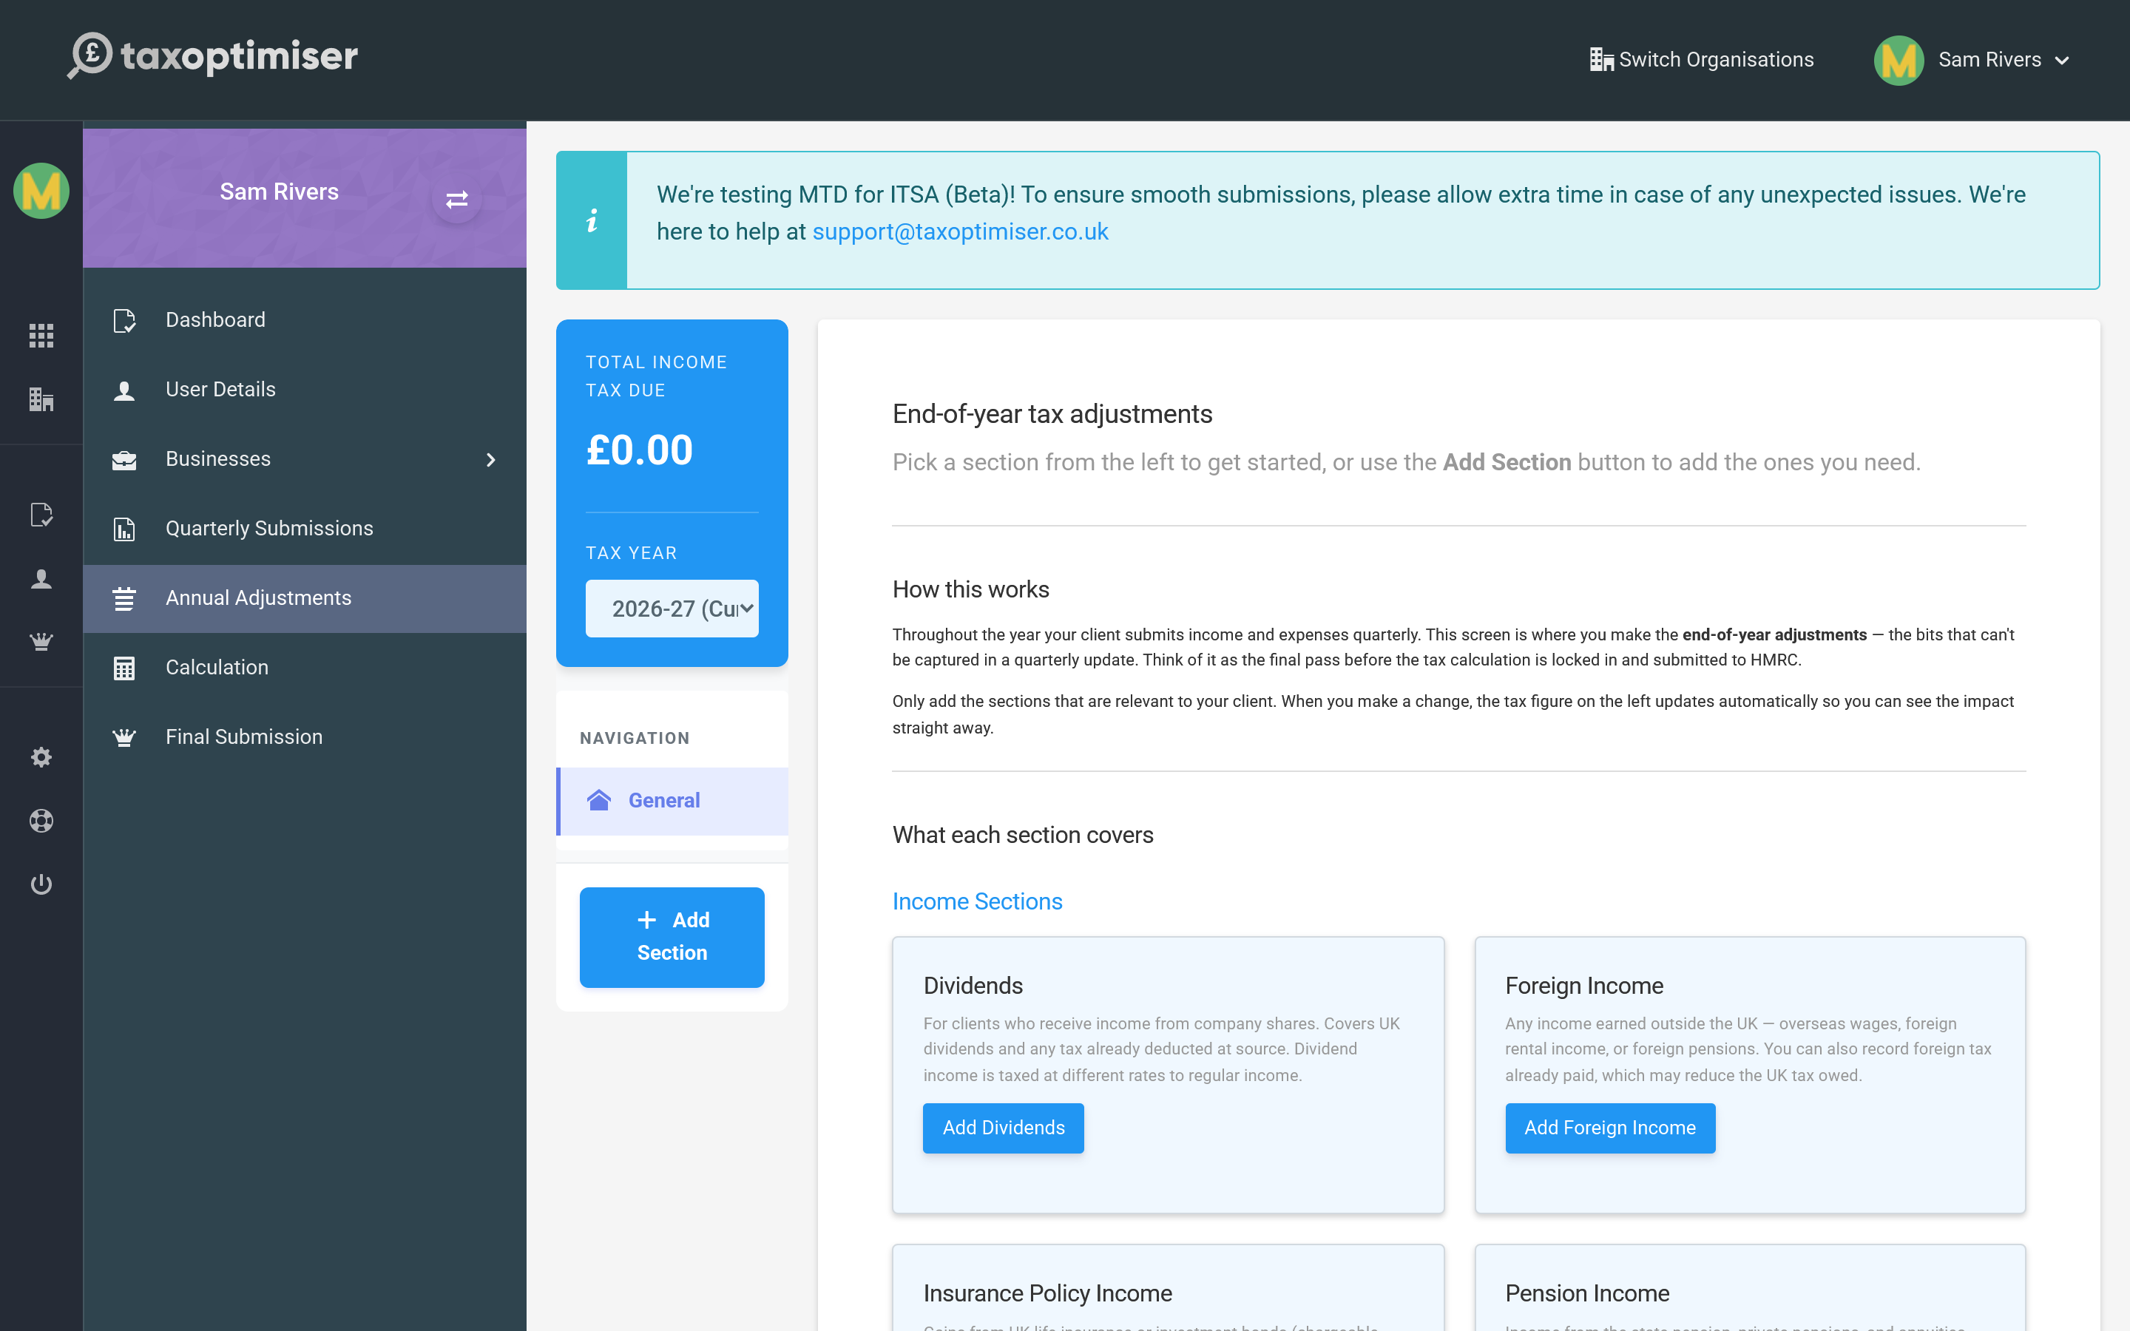

How it works
Pick a section from the left, or use Add Section to add the ones relevant to you. You only complete the sections that apply — and as you do, the income tax due figure on the left updates so you can see the effect of each change straight away.

What you can add here
The sections cover the income and reliefs that sit outside your quarterly business updates, for example:
- Dividends from company shares, taxed at their own rates.
- Foreign income — overseas wages, pensions or rental income.
- Pension income and contributions, and Gift Aid donations.
- Other taxable income, savings and investment income, and any reliefs or losses to claim.
Think of this screen as the final tidy-up: everything that is true for the whole year rather than a single quarter goes here, ready to feed into the calculation.

9. Your tax calculation
Asking HMRC to work out the tax on what you have reported, the three kinds of calculation, and how to read the result.
IN SHORT
- Request Calculation asks HMRC for a fresh figure; Retrieve fetches the latest
- In-year = a running estimate; intent to finalise = pre-declaration; intent to amend = after finalising
- Results show your income tax liability plus the calculation's details
- An in-year figure is only an estimate and changes as you report more

At any point in the year you can ask HMRC to add up everything you have reported so far — quarterly updates and annual adjustments — and tell you the tax it implies. Open Calculation.
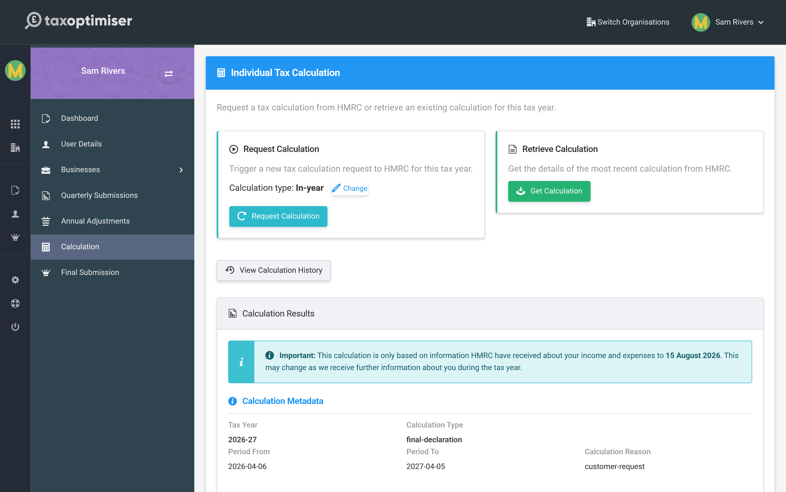

Requesting a calculation
Request Calculation asks HMRC for a fresh figure; Retrieve Calculation fetches the most recent one HMRC already holds. There are three kinds of request:
- In-year — a running estimate part-way through the year, based on what you have sent so far.
- Intent to finalise — the calculation you review just before submitting your final declaration.
- Intent to amend — a recalculation when you need to change a year you have already finalised.

Reading the result
The Calculation Results show your income tax liability along with the calculation’s details — the tax year it covers, its type and the date it was produced. Remember an in-year figure is only an estimate: HMRC notes it is based on the information received so far, and it will move as you report more.
You can also open View Calculation History to compare earlier calculations against the latest.

10. The final declaration and managing tax years
The once-a-year declaration that crystallises your tax bill, what must be done first, and how to re-open a year to amend it.
IN SHORT
- The final declaration crystallises your tax bill and replaces the SA return
- All quarterly updates and annual adjustments must be in first
- It is a three-step, legally-binding confirmation
- Years are Open then Closed; re-open a closed year to amend and re-finalise

The final declaration — sometimes called crystallisation — is the once-a-year step that replaces the old Self Assessment return. It tells HMRC that everything you have reported for the year is complete and correct, and it fixes your tax bill for that year. Open Final Submission.
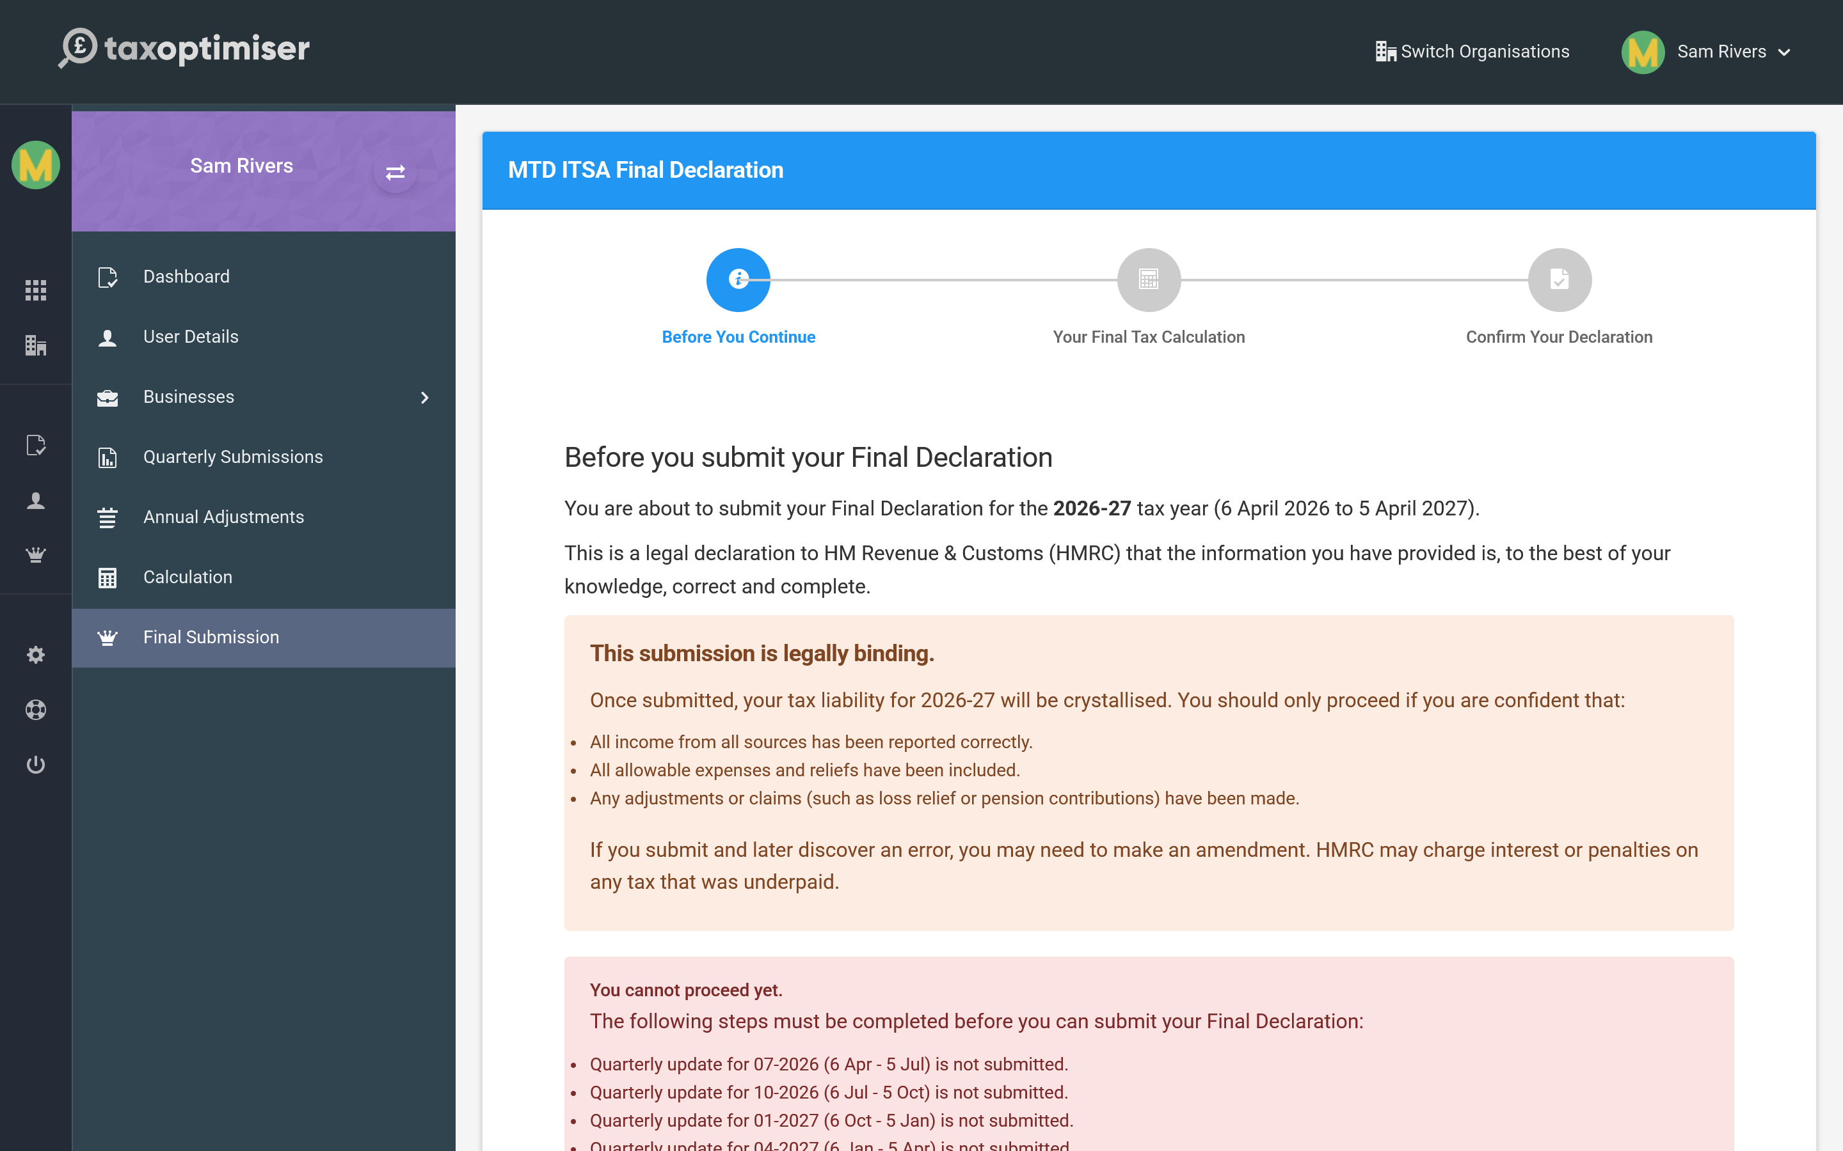

Before you can submit
The declaration covers all your income, so you can only make it once the year is complete: every quarterly update submitted, and any annual adjustments entered. If something is still outstanding, the wizard lists exactly what — finish those first and come back.

The three steps
- Before you continue — a checklist of what the declaration includes, and a reminder that it is legally binding.
- Your final tax calculation — the figure HMRC will crystallise, for you to review one last time.
- Confirm your declaration — you confirm the information is correct and complete, and submit.
The final declaration is a legal statement to HMRC. Once submitted, your tax liability for the year is crystallised. Only proceed when you are confident every source of income, expense and relief has been reported — if you find an error later you may need to make an amendment, and HMRC can charge interest on any tax that was underpaid.

Managing tax years
Each tax year is Open while you are still reporting, and becomes Closed once you submit the final declaration. If you later discover a change is needed, you can re-open the year for amendment — this lets you adjust the figures and re-finalise. A re-opened year is marked as amended so the change is clear.

