SA800 Partnership Returns
User Guide (beta)
Preparing and filing the Partnership Tax Return in Tax Optimiser — creating a partnership period, the details and declarations, trading income, the balance sheet, the Partnership Statement, supplementary pages, and submitting to HMRC.
Beta feature — Partnership (SA800) returns are currently in beta and are switched on for one accountant firm at a time. To gain access for your firm, email support@taxoptimiser.co.uk and the team will enable it and help you get started.
taxoptimiser.co.uk · 4 July 2026

Contents
- Partnership (SA800) returns in Tax Optimiser (beta) — Prepare and file SA800 Partnership Tax Returns for LLP and partnership clients: a six-step wizard, self-calculating boxes, the official form as a PDF, and direct HMRC filing.
- Getting started with SA800 returns — Where the LLP (SA800) menu appears, what the returns list shows, and what New Partnership Period prefills for you.
- SA800 details, declarations and the page 2 questions — The Details step: partnership name and live-checked UTR, boxes 3.1/3.2, period dates, the agent and amended-return declarations, and the page 2 questions.
- SA800 trading income and expenses — The full SA800 income and expenses page: entering income and expense totals, capital allowances, and how the calculated boxes 3.65 and 3.73 drive the rest of the return.
- The SA800 balance sheet — Boxes 3.99 to 3.115: assets, liabilities and the partners' accounts, with all three totals calculated and a built-in way to check the sheet balances.
- The Partnership Statement: partners and profit shares — Adding partners, boxes 6-12, entering each partner's share, and the live checks: the allocation-vs-return warning and the UTR check that prevents error 8205.
- SA800 supplementary pages (SA801-SA804) — Land & Property, Foreign, Chargeable Assets and Savings on one screen - each page files only when it carries figures, and SA801's net position calculates itself.
- Reviewing, printing and submitting the SA800 — The review summary and its two warnings, printing the official SA800 form, what Submit really does (sign, send, poll), and handling rejections and amendments.

1. Partnership (SA800) returns in Tax Optimiser (beta)
Prepare and file SA800 Partnership Tax Returns for LLP and partnership clients: a six-step wizard, self-calculating boxes, the official form as a PDF, and direct HMRC filing.
IN SHORT
- SA800 returns for LLP and partnership clients, in a six-step wizard
- Calculated boxes (3.65, 3.73, balance sheet totals) are derived automatically
- SA801/SA802/SA803/SA804 supplementary pages included
- Print the official SA800 form and file directly to HMRC
- BETA: email support@taxoptimiser.co.uk to enable it for your firm

Tax Optimiser can now prepare and file the SA800 Partnership Tax Return for client partnerships — the annual return every UK partnership must send to HMRC, reporting the business’s income and how the profit was shared between the partners. You enter the return in a six-step wizard, the arithmetic boxes calculate themselves as you type, you can print the official SA800 form at any point, and you submit to HMRC without leaving Tax Optimiser.

Who this is for
The feature applies to client organisations whose structure is a Limited Liability Partnership or an ordinary Partnership — the LLP (SA800) menu section only appears for those organisations. The partnership itself pays no tax on the return: the SA800 reports the results and the Partnership Statement allocates them, and each partner then carries their own share onto the partnership pages of their personal return. If you also prepare the partners’ personal Self Assessment returns, Tax Optimiser’s Self Assessment (beta) feature covers those, including the SA104 partnership pages.

What is supported today
The beta supports the 2025-26 return with:
- The full trading income & expenses page (boxes 3.29–3.73) — also valid below the £90,000 three-line-accounts threshold, so one screen serves every size of partnership
- The summary balance sheet (boxes 3.99–3.115)
- The Partnership Statement — any number of partners, with each share checked against the return
- The supplementary pages: Land & Property (SA801), Foreign (SA802), Chargeable Assets (SA803) and Savings (SA804)
- Partner and agent declarations, and amended returns
- A populated, printable copy of the official SA800 form
- Direct filing to HMRC over their online channel, with the return signed and acknowledged end to end
Every calculated box on the form — net profit (3.65), net business profit for tax (3.73), the balance sheet totals, the partners’ closing balance — is derived for you and shown read-only, so the return can never disagree with its own arithmetic.
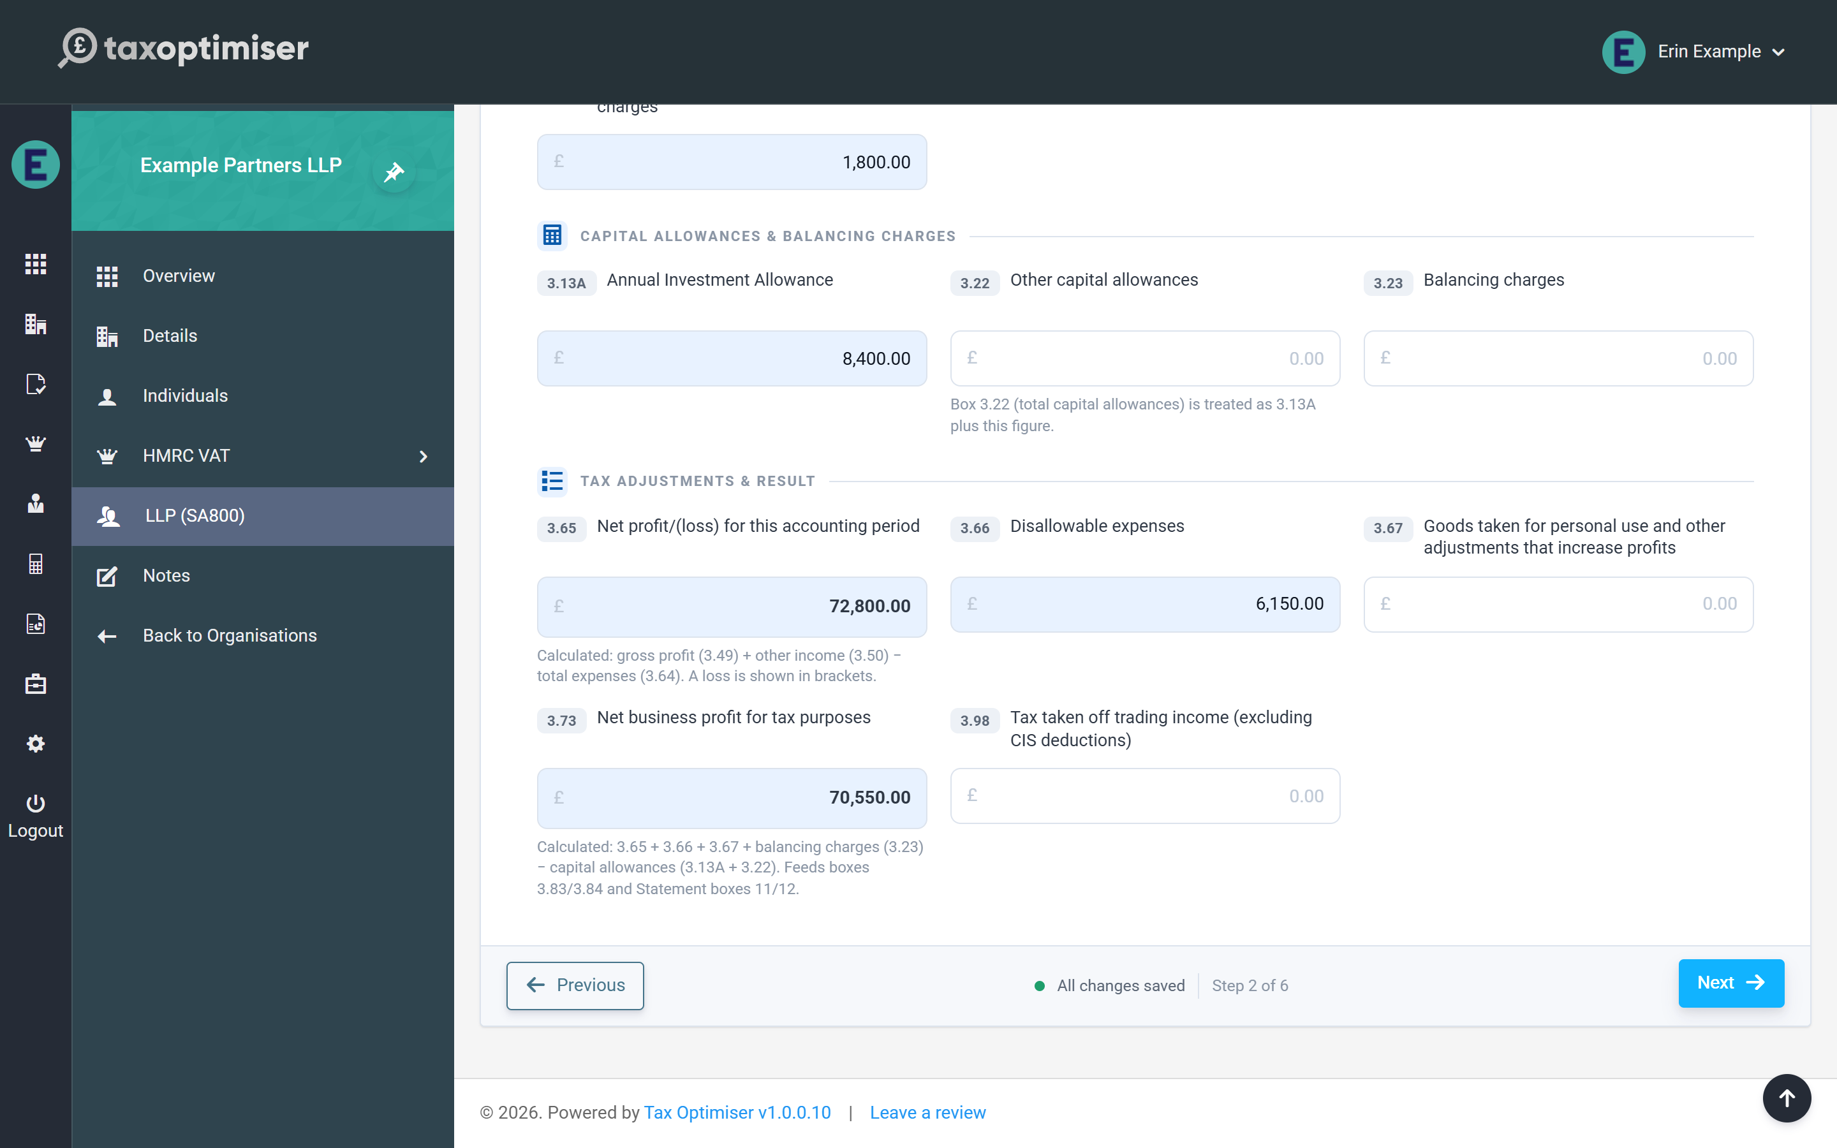

How the return comes together
The wizard walks the form in the order an accountant naturally works: partnership details, trading income, balance sheet, partners, supplementary pages, then a review step that summarises the whole return before anything is sent.
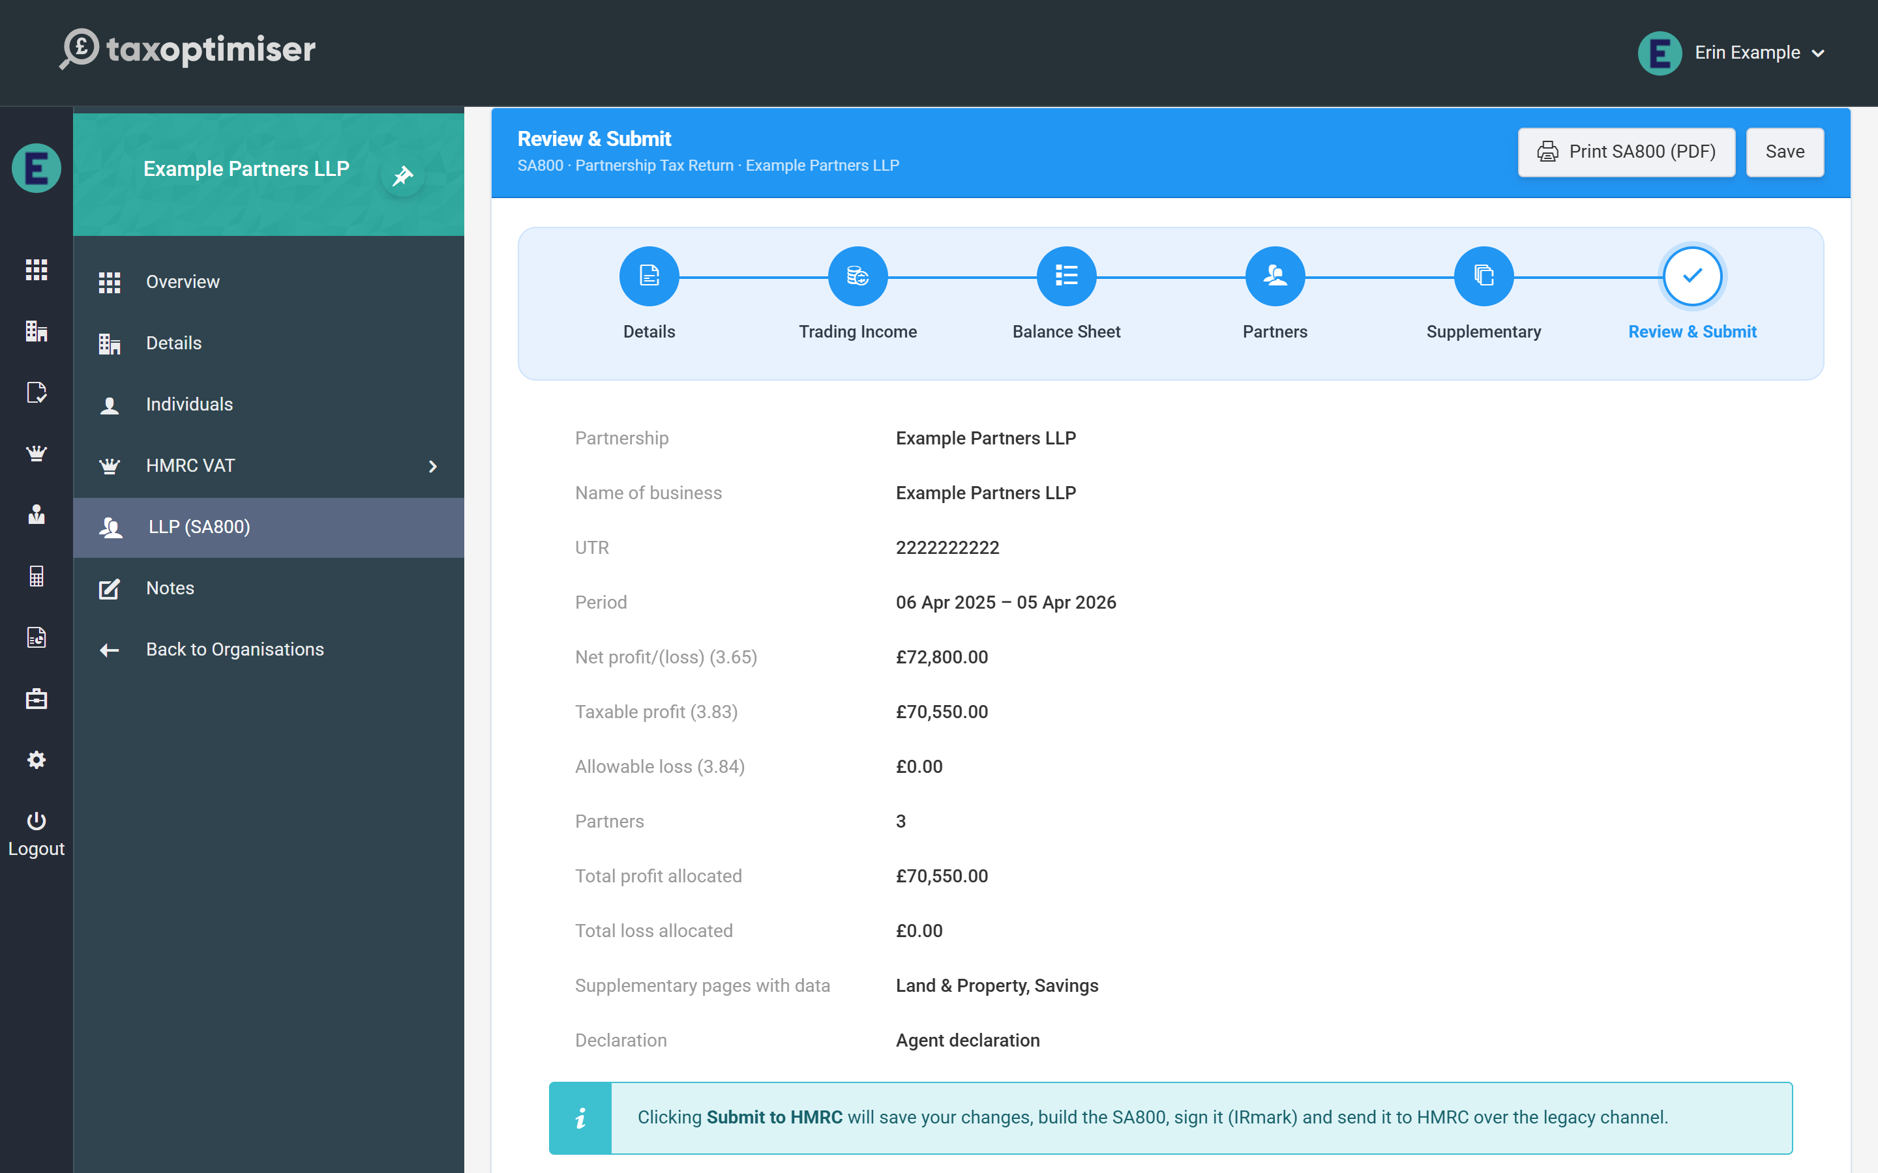

2. Getting started with SA800 returns
Where the LLP (SA800) menu appears, what the returns list shows, and what New Partnership Period prefills for you.
IN SHORT
- LLP (SA800) menu appears only for partnership-structured organisations
- Statuses: Ready to start, Preparing, Ready for review, Submitted, Complete, Archived
- New periods default to the latest 6 April - 5 April tax year
- Verify the due date: online filing deadline is 31 January
- BETA: email support@taxoptimiser.co.uk to enable it for your firm

SA800 returns hang off a partnership period — the partnership’s equivalent of an accounting period, created and managed from the LLP (SA800) menu.

Before you start: the organisation must be a partnership
The LLP (SA800) menu section only appears when the selected organisation’s company structure is Limited Liability Partnership or Partnership. If you can’t see it for a client, check the structure type on the organisation’s details first — and remember the feature is in beta, so it also needs to be enabled for your firm (email support@taxoptimiser.co.uk).

The returns list
Selecting LLP (SA800) opens the partnership’s returns list: one row per period showing the partnership name, period start and end, how many partners are on the statement, and the period’s status.
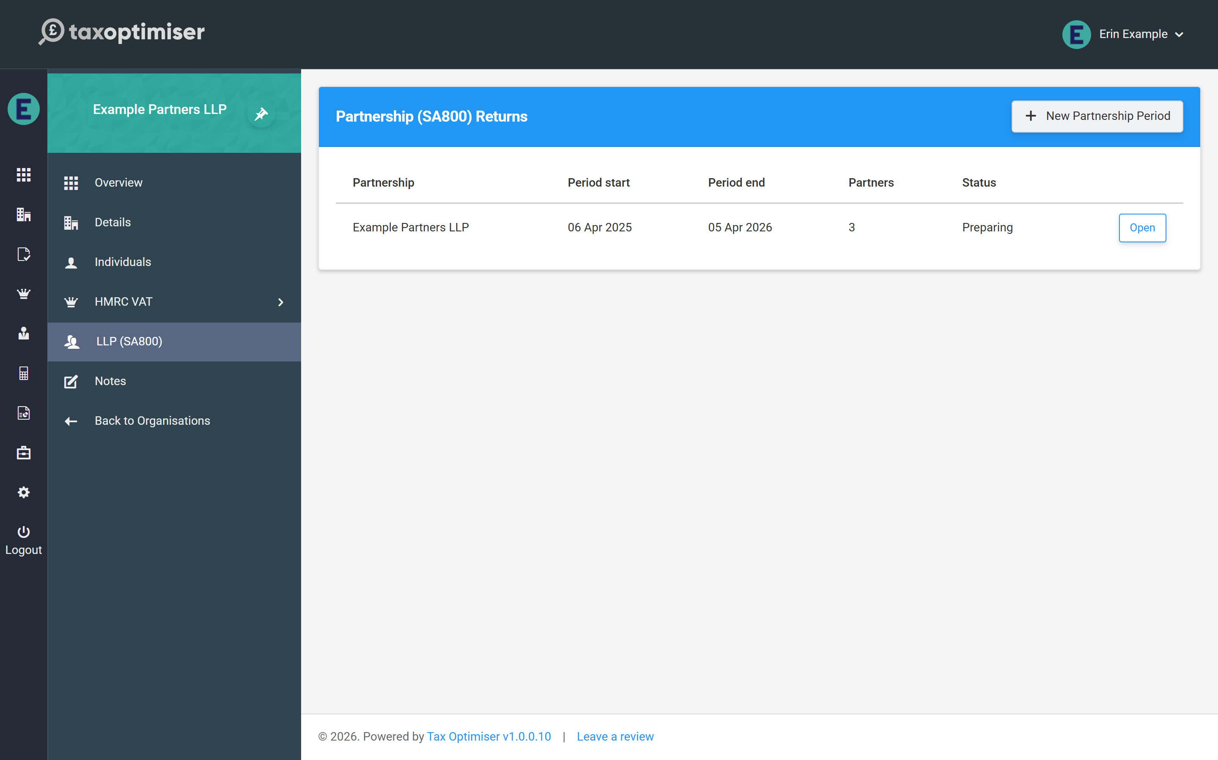
A period moves through the statuses Ready to start → Preparing → Ready for review → Submitted → Complete (with Archived for periods you no longer need in view).

Creating a period
Click New Partnership Period. Tax Optimiser creates the period and opens the return wizard straight away, prefilled with sensible defaults:
- Period dates default to the most recent tax year (6 April to 5 April) — change them if the partnership’s accounts are drawn to a different date
- The partnership name is taken from the organisation
- The UTR is prefilled from the tax reference held on the organisation’s details, if there is one
Check the filing due date on the Details step: for a return filed online the deadline is 31 January after the end of the tax year, and the prefilled date is only an approximation of that.

3. SA800 details, declarations and the page 2 questions
The Details step: partnership name and live-checked UTR, boxes 3.1/3.2, period dates, the agent and amended-return declarations, and the page 2 questions.
IN SHORT
- UTR is checked as you type; fix failures before submitting (HMRC error 8205)
- Box 3.1 falls back to the partnership name if blank
- Tick box 11.3.1 when the agent makes the declaration
- Use box 3.116 to explain provisional figures or unusual periods
- BETA: email support@taxoptimiser.co.uk to enable it for your firm

The first step of the wizard captures the partnership’s identity and the whole-return declarations — everything on the front of the SA800 plus the yes/no questions from page 2.

The partnership’s identity
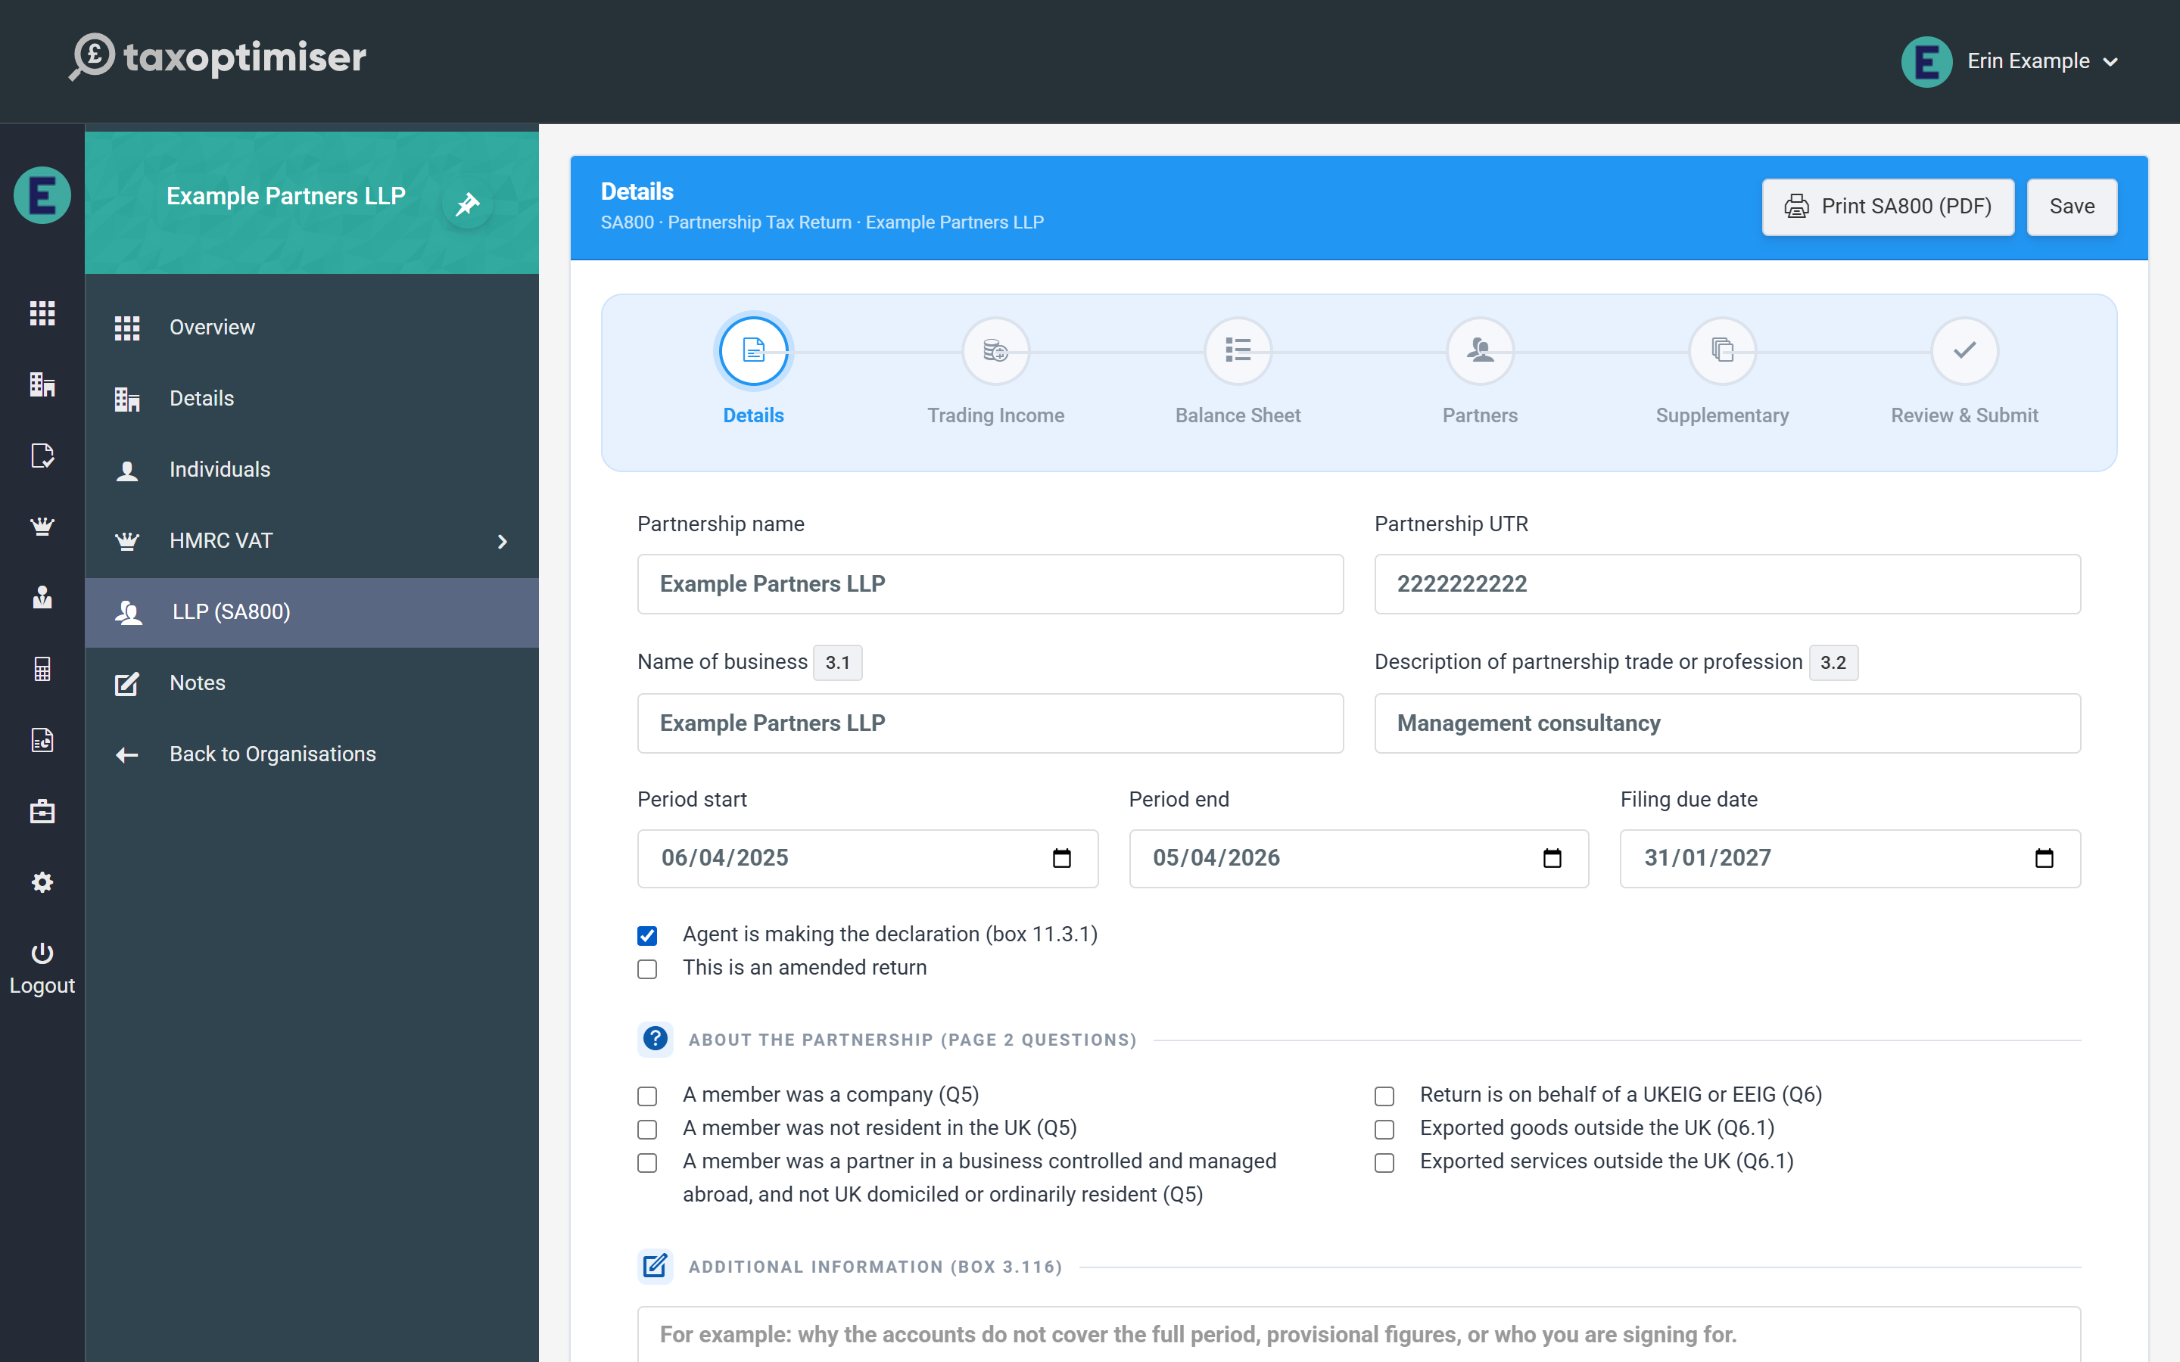
- Partnership name and Partnership UTR — the UTR is checked as you type against HMRC’s own check-digit rule. A UTR that fails the check turns the field red immediately: HMRC rejects a return carrying a bad UTR outright (error 8205), so it is worth fixing here rather than at submission.
- Name of business (box 3.1) and Description of partnership trade or profession (box 3.2) — box 3.1 falls back to the partnership name if left blank.
- Period start / end and the filing due date.

Declarations
Two checkboxes control how the return is signed off:
- Agent is making the declaration (box 11.3.1) — tick this when your firm declares on the partnership’s behalf; leave it clear for a partner declaration.
- This is an amended return — tick when re-filing a return HMRC has already accepted; the submission is flagged as an amendment and replaces the original.

The page 2 questions and additional information
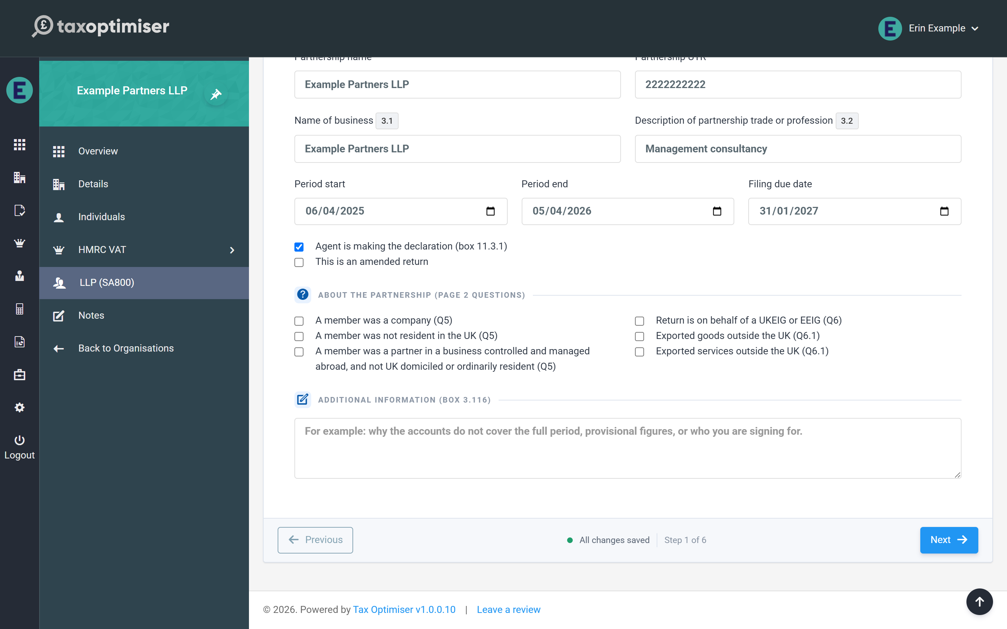
The six checkboxes mirror questions 5, 6 and 6.1 on page 2 of the form: whether any member was a company, was not UK resident, or was a partner in a business controlled and managed abroad; whether the return is on behalf of a UKEIG or EEIG; and whether the partnership exported goods or services outside the UK.
Additional information (box 3.116) is the free-text box HMRC reads for anything that needs explaining — for example why the accounts don’t cover the full period, provisional figures, or who you are signing for.

4. SA800 trading income and expenses
The full SA800 income and expenses page: entering income and expense totals, capital allowances, and how the calculated boxes 3.65 and 3.73 drive the rest of the return.
IN SHORT
- One full income & expenses page for every partnership, any size
- Enter expenses gross; add back disallowables in box 3.66
- 3.65 and 3.73 calculate themselves and cannot be mistyped
- 3.73 feeds boxes 3.83/3.84 and the partner allocation
- BETA: email support@taxoptimiser.co.uk to enable it for your firm

The Trading Income step is the heart of the return: the SA800’s full income & expenses page (boxes 3.29–3.73). Tax Optimiser implements the full page for every partnership — it is also valid below the £90,000 three-line-accounts threshold, so there is one screen to learn regardless of the client’s size.

Entering the figures
Every money box works the same way: type the amount (the £ sign, commas and spaces are all tolerated), and boxes that can go negative accept brackets — (1,500) means minus 1,500, matching how the form itself shows losses. Boxes with a grey tint are calculated and read-only; each one explains its own arithmetic underneath.
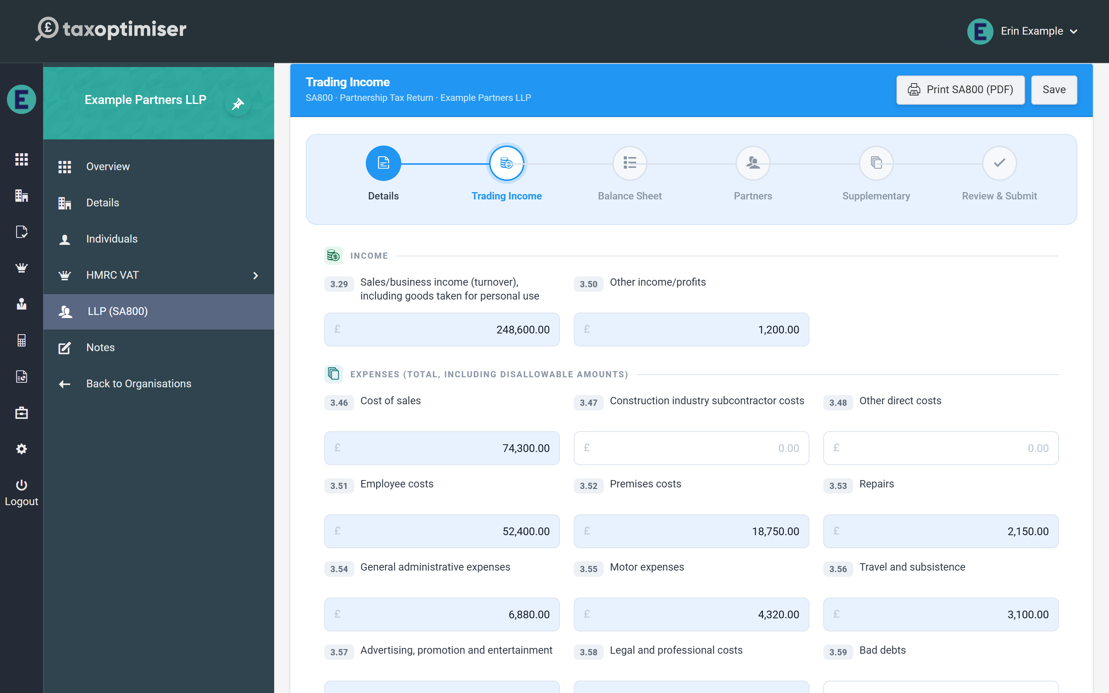

Income and expenses
- Income: sales/business income (box 3.29, including goods taken for personal use) and other income/profits (3.50).
- Expenses (boxes 3.46–3.63): entered at their full amounts including any disallowable part — cost of sales, subcontractor costs, employee costs, premises, repairs, admin, motor, travel, advertising, legal, bad debts, interest and finance charges, depreciation, and other expenses. The disallowable total is added back separately in box 3.66.

Capital allowances and the calculated result
- Annual Investment Allowance (3.13A), other capital allowances (3.22) and balancing charges (3.23).
- Net profit/(loss) (3.65) — calculated: gross profit (3.49) + other income (3.50) − total expenses (3.64).
- Disallowable expenses (3.66) and goods taken for personal use (3.67) add back to profit.
- Net business profit for tax purposes (3.73) — calculated: 3.65 + 3.66 + 3.67 + balancing charges − capital allowances. This figure drives the whole return: a positive result becomes the taxable profit (3.83) and a negative one the allowable loss (3.84), and those are exactly what the Partnership Statement must allocate to the partners.
- Tax taken off trading income (3.98) for any tax already deducted at source (excluding CIS deductions).

5. The SA800 balance sheet
Boxes 3.99 to 3.115: assets, liabilities and the partners' accounts, with all three totals calculated and a built-in way to check the sheet balances.
IN SHORT
- Totals 3.105/3.109/3.110/3.115 are calculated for you
- 3.112 mirrors box 3.65 automatically
- Brackets mean negative, matching the paper form
- Check 3.115 = 3.110 to prove the sheet balances
- BETA: email support@taxoptimiser.co.uk to enable it for your firm

The Balance Sheet step covers the SA800’s summary balance sheet (boxes 3.99–3.115) — a condensed snapshot of the partnership’s position at the period end, with all three totals calculated for you.

Assets and liabilities
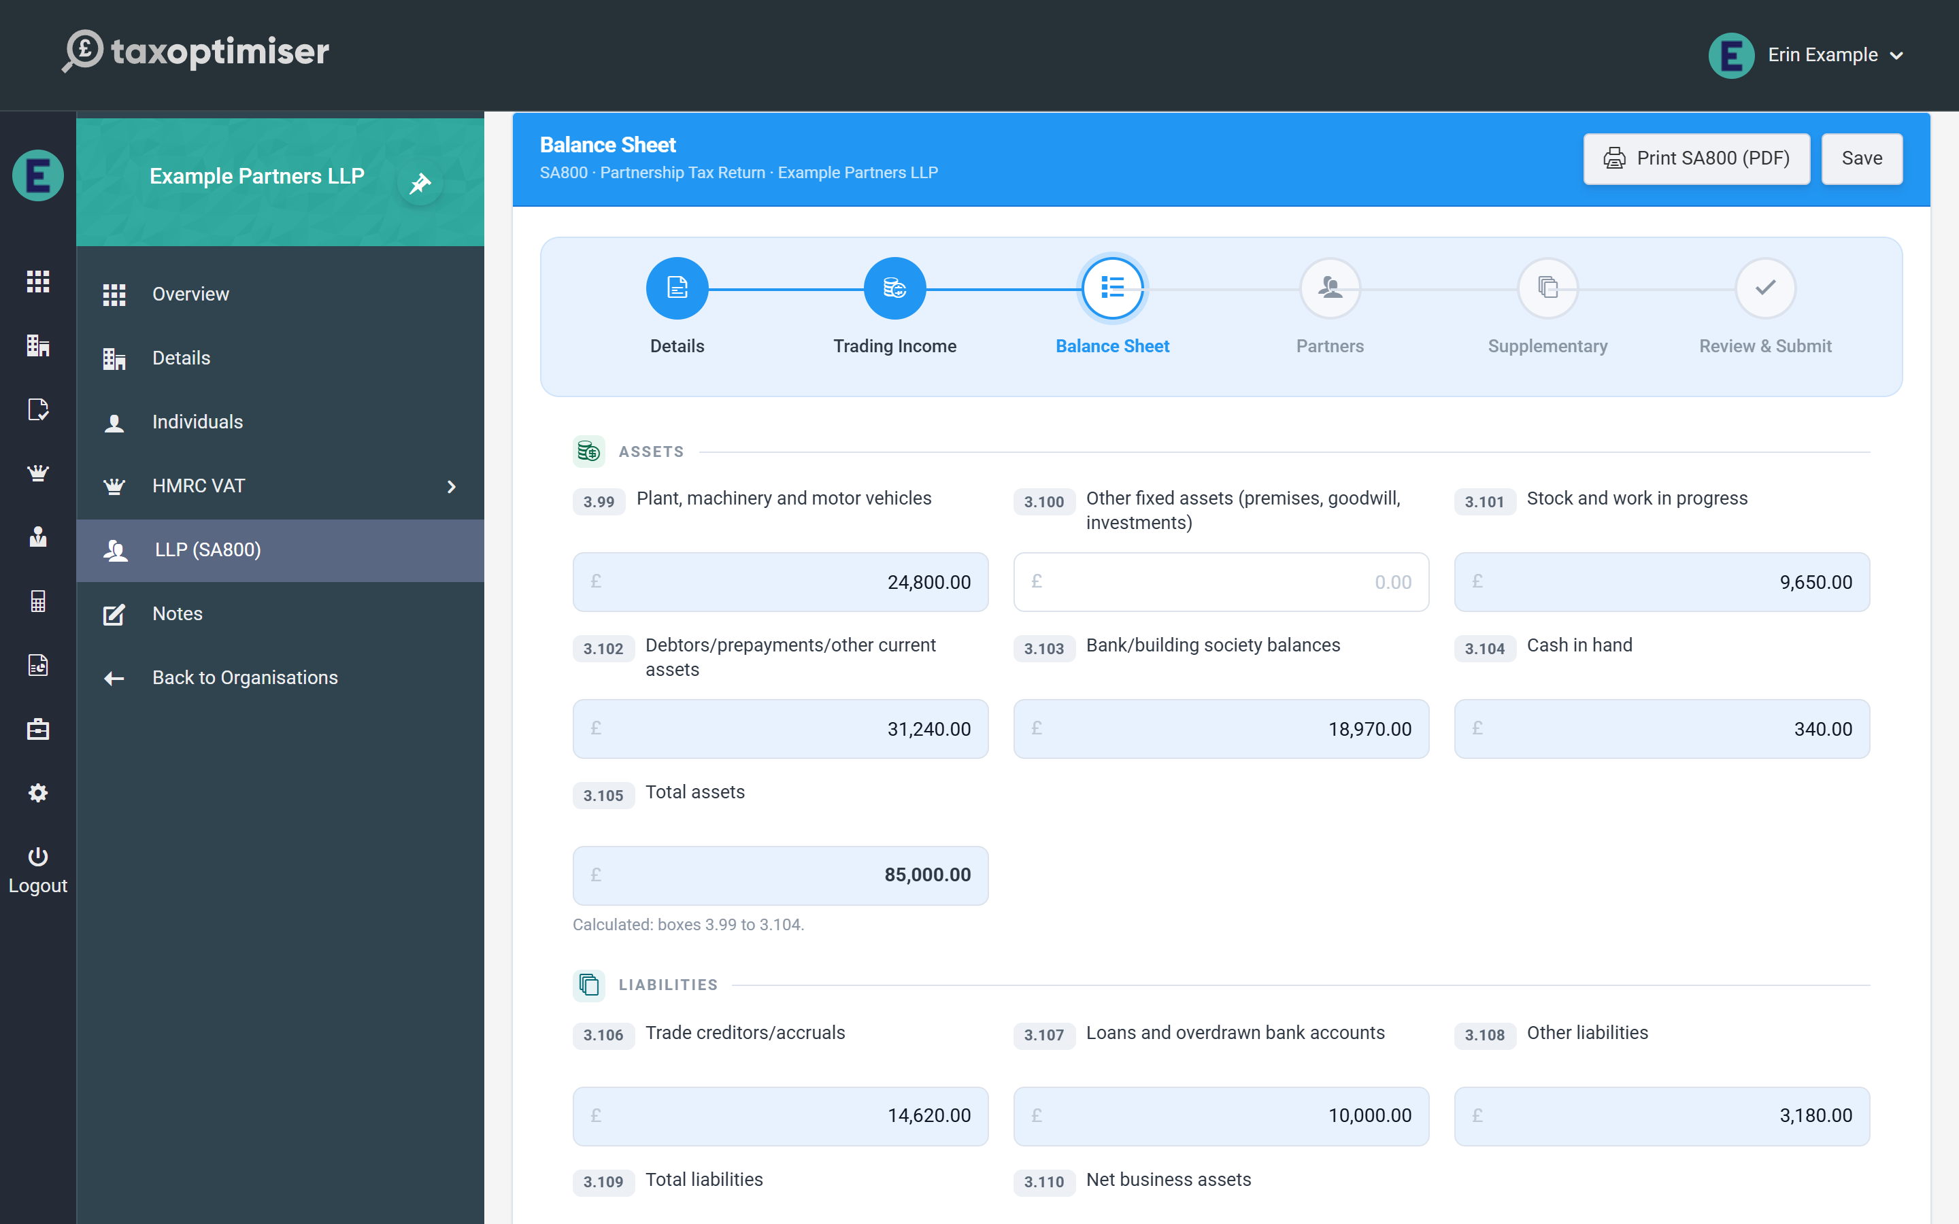
- Assets (3.99–3.104): plant, machinery and vehicles; other fixed assets; stock and work in progress; debtors and prepayments; bank balances; cash. Total assets (3.105) is calculated.
- Liabilities (3.106–3.108): trade creditors and accruals; loans and overdrawn bank accounts; other liabilities. Total liabilities (3.109) is calculated.
- Net business assets (3.110) — calculated as 3.105 minus 3.109; net liabilities show in brackets.

Partners’ current and capital accounts
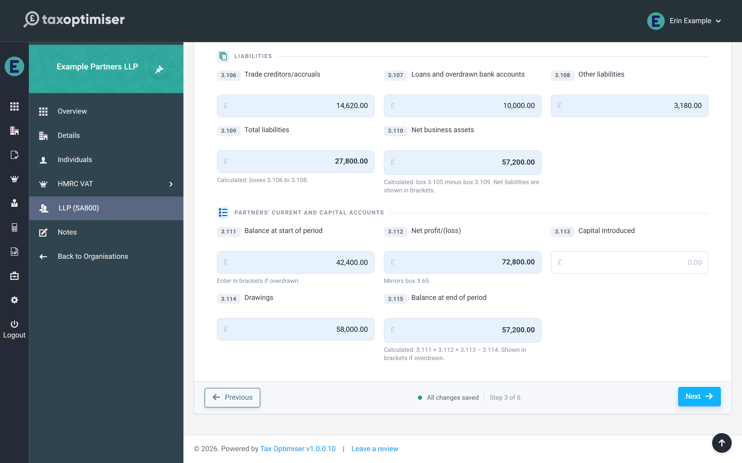
The final group reconciles the partners’ combined accounts across the period:
- Balance at start of period (3.111) — enter in brackets if overdrawn
- Net profit/(loss) (3.112) — mirrors box 3.65 from the Trading Income step automatically
- Capital introduced (3.113) and drawings (3.114)
- Balance at end of period (3.115) — calculated: 3.111 + 3.112 + 3.113 − 3.114
A useful cross-check before moving on: on a balance sheet that balances, the closing balance in 3.115 equals net business assets in 3.110. If the two disagree, an asset, liability or drawings figure is missing or mistyped.

6. The Partnership Statement: partners and profit shares
Adding partners, boxes 6-12, entering each partner's share, and the live checks: the allocation-vs-return warning and the UTR check that prevents error 8205.
IN SHORT
- One row per partner: boxes 6, 8, 10, 11, 12 plus address and dates 7/9
- Enter shares directly; the percentage column is informational
- Shares must total 3.83 (profit) and 3.84 (loss) - live warning if not
- A single bad partner UTR = whole return rejected (8205)
- BETA: email support@taxoptimiser.co.uk to enable it for your firm

The Partners step is the SA800’s Partnership Statement — the schedule that tells HMRC who the partners were and how the period’s result was divided between them. Each partner takes their share from here onto their own personal return.

Adding partners
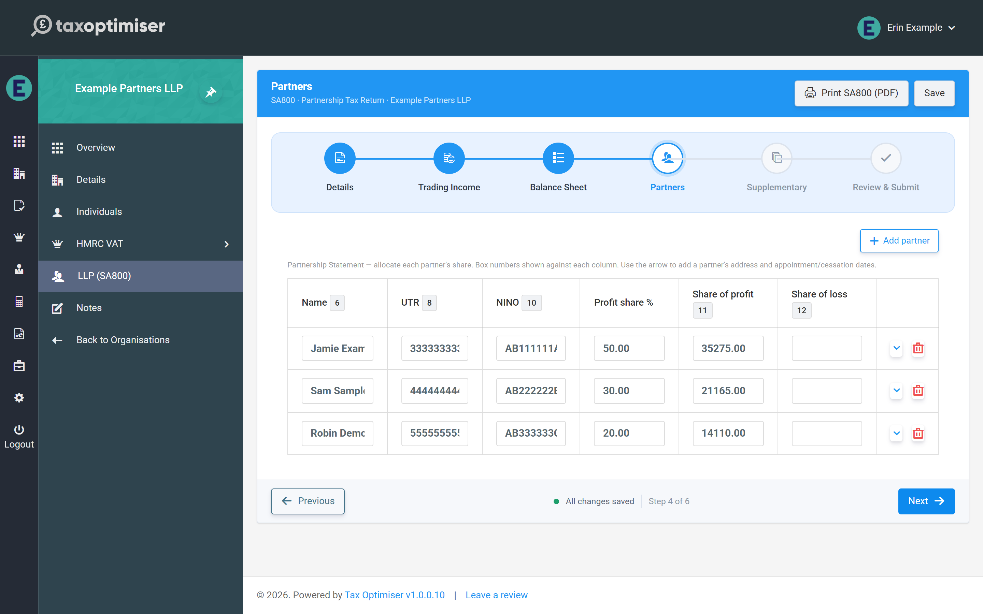
Click Add partner for each partner. The table columns carry the statement’s box numbers: name (box 6), the partner’s own UTR (box 8), National Insurance number (box 10), and the shares of profit (box 11) and loss (box 12). The arrow at the end of each row opens the partner’s detail panel for their address and, where relevant, date appointed (box 7) or date ceased (box 9) — only enter those dates if they fall during 2024-25 or 2025-26.
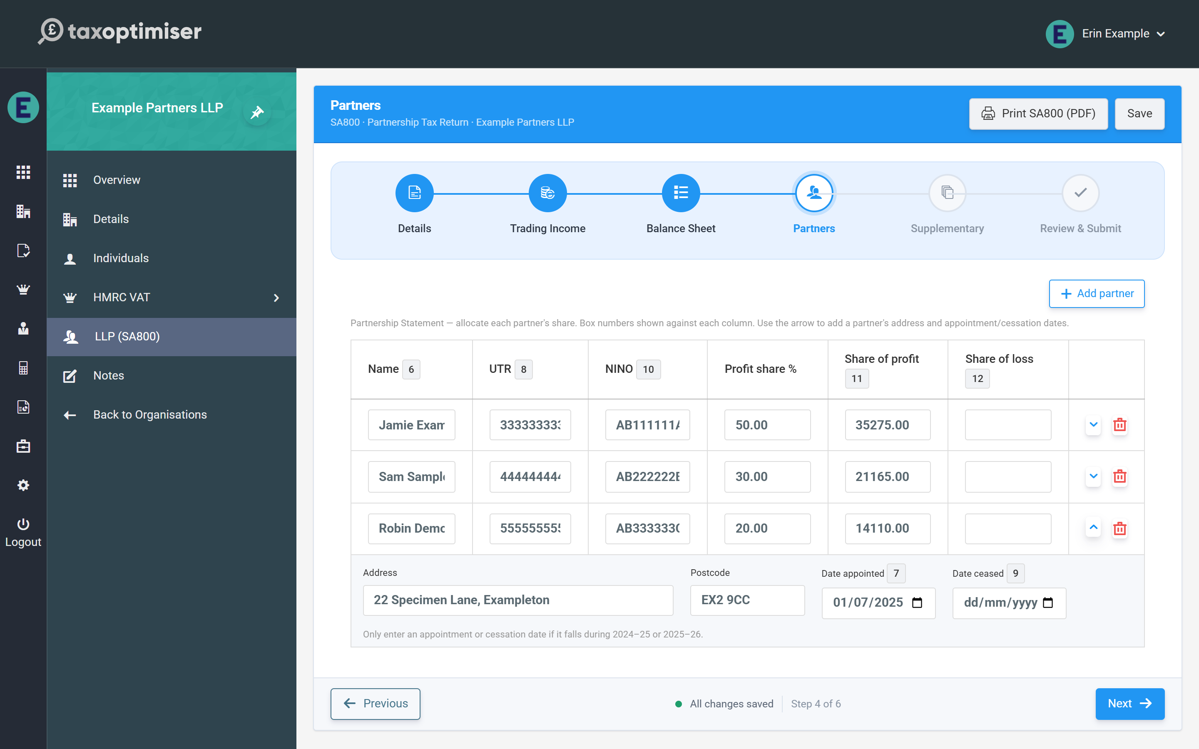

Allocating profit shares
Enter each partner’s share of the result directly — the profit share % column is recorded on the statement but the money boxes are what HMRC reads, so agreements with fixed shares, salaries or interest on capital can be entered exactly as computed. The rule the statement must obey is simple: the partners’ shares must add up to the return — box 11 shares to the taxable profit (3.83), box 12 shares to the allowable loss (3.84).
Tax Optimiser totals the shares live and shows a warning whenever they don’t match the return, quoting both figures so you can see the gap at a glance. The warning also appears on the Review step, but it never blocks saving — you can leave the allocation half-done and come back.
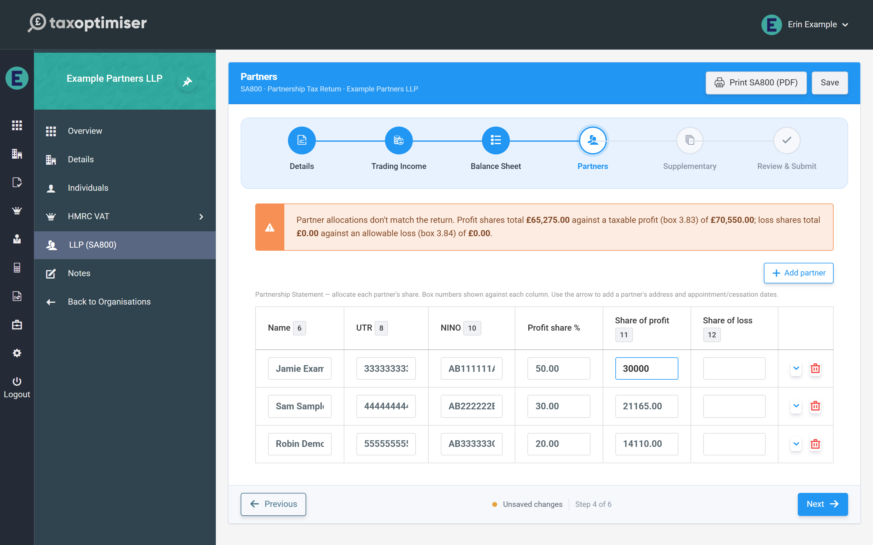

The checks that stop an HMRC rejection
Two per-partner checks run as you type:
- Partner UTR — validated against the same HMRC check-digit rule as the partnership’s own UTR. One bad partner UTR causes HMRC to reject the whole return (error 8205), so the field turns red immediately.
- NINO — checked for the standard format (two letters, six digits, final letter A–D). This is a soft check; HMRC treats partner NINOs as optional.

7. SA800 supplementary pages (SA801-SA804)
Land & Property, Foreign, Chargeable Assets and Savings on one screen - each page files only when it carries figures, and SA801's net position calculates itself.
IN SHORT
- All four supplementary pages on one step
- Pages with no figures are simply not filed - nothing to toggle
- SA803 is proceeds-only: partners compute their own gains
- SA801 net profit/(loss) is calculated for you
- BETA: email support@taxoptimiser.co.uk to enable it for your firm

Partnerships with income beyond the trade report it on the SA800’s supplementary pages. The Supplementary step gathers all four on one screen; a page is only included in the submission when it actually carries figures, and the Review step lists which pages will go (“Supplementary pages with data”).
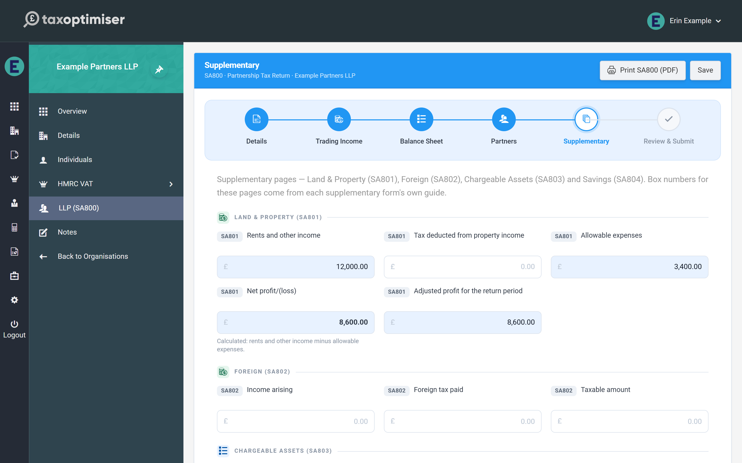

Land & Property (SA801)
Rental business income: rents and other income, any tax deducted from it, and allowable expenses. The net profit/(loss) is calculated (income minus expenses), and the adjusted profit for the return period carries any adjustments you compute.

Foreign (SA802)
Overseas income: the income arising, foreign tax paid on it, and the taxable amount.

Chargeable Assets (SA803)
The partnership reports only the disposal proceeds from chargeable assets sold in the period. That is deliberate — a partnership isn’t itself chargeable to capital gains tax, so each partner computes their own gain or loss on their share via their personal return.

Savings (SA804)
Investment income: untaxed UK bank and building society interest, gross (box 7.9A), tax deducted from savings income, and other savings income.
Like the main pages, anything the form derives is calculated read-only, and leaving a page untouched simply leaves it out of the filing — there is nothing to switch on or off.

8. Reviewing, printing and submitting the SA800
The review summary and its two warnings, printing the official SA800 form, what Submit really does (sign, send, poll), and handling rejections and amendments.
IN SHORT
- Fix both Review warnings before submitting
- The printed PDF uses saved figures - save first
- Submit = save, build, IRmark sign, send, poll for the outcome
- Amend an accepted return via the amended-return flag on Details
- BETA: email support@taxoptimiser.co.uk to enable it for your firm

The final step pulls the whole return together: a summary to review, the official form to print, and the submission itself.

The final checks
The summary shows the partnership, business name, UTR, period, the headline figures (net profit 3.65, taxable profit 3.83, allowable loss 3.84), the partner count against the totals actually allocated, which supplementary pages carry data, and the declaration type. Two warnings can appear here and both deserve fixing before you submit:
- UTR check — if the partnership’s or any partner’s UTR fails the check digit, submission is guaranteed to be rejected with error 8205
- Allocation mismatch — the partners’ shares don’t add up to the return’s boxes 3.83/3.84

Printing the official form
Print SA800 (PDF) renders the partnership’s figures onto the official HMRC SA800 form — ideal for a review file or for the client’s records. The button appears in the wizard header throughout, and one caution applies: the PDF is built from saved figures, so click Save first if you have just made changes (the footer tells you when there are unsaved changes).
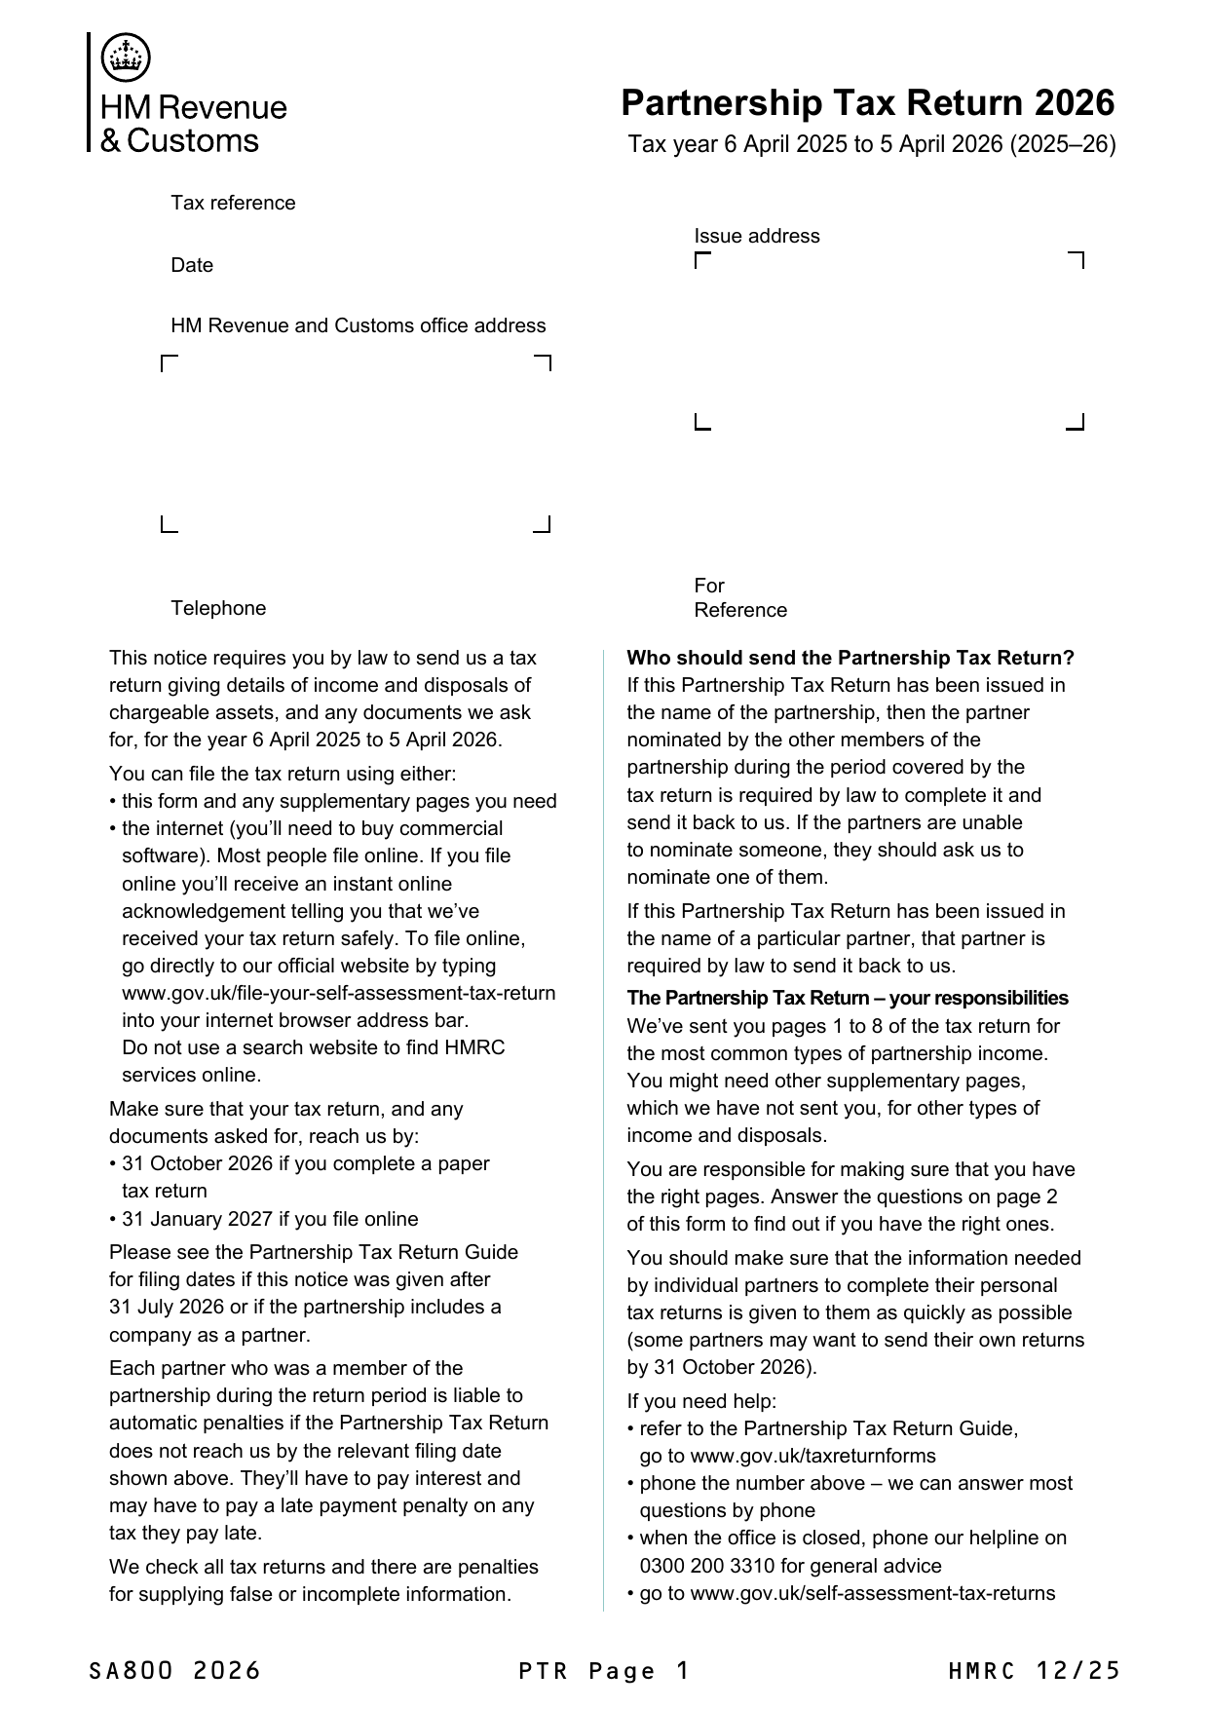

What Submit to HMRC actually does
Clicking Submit to HMRC saves your changes, builds the SA800 from the saved return, signs it with an IRmark (the tamper-evident signature HMRC requires), sends it over HMRC’s online channel, and then polls until HMRC confirms the outcome — you watch a single progress screen until the return is accepted or rejected. On success the screen confirms “SA800 submitted to HMRC” and the period moves through Submitted towards Complete.

If something goes wrong
A rejection shows HMRC’s response on screen — fix the return and submit again. For an amended return (one HMRC has already accepted), tick This is an amended return on the Details step before resubmitting and the new filing replaces the original. Every submission’s full exchange with HMRC is logged, so if anything looks stuck, email support@taxoptimiser.co.uk and the team can trace the filing end to end.

